**Cleanup:**

**Mobile App Connecting Providers with Customers**

**of Cleaning Services**

Senior Project

by

**Aya H Mhanna,**

**Batoul M Sleiman**

Submitted to the School of Engineering of the

Lebanese International University

Tyre, Lebanon

in partial fulfillment of the requirements for the degree of

**BACHELOR OF SCIENCE IN COMMUNICATION ENGINEERING**

**Spring 2022-2023**

**Approved by:**

**Supervisor**

Dr. Ahmad Kobeissi

**Committee Member**

Dr. Hadi Noureddine

**DEDICATION**

*This project is dedicated to my beloved parents, the greatest influencers in my life, who.*

*taught me that everything can be accomplished with hard work, dedication, and self-.*

*discipline. Thank you for your love, support, and putting me through the best education.*

*possible. Thank you all for your invaluable contributions to this project.* *I have special gratitude to my best partner and my close friends, who have been always by my side throughout my senior journey.*

Batoul M. Sleiman

*This project is a heartfelt dedication to my parents, with special mention to my father, who has always believed in my abilities and supplied constant reinforcement. My mother's unwavering presence has been my rock and source of unwavering support to the invisible hands that have lovingly embraced and guided me through every triumph and challenge. To my amazing partner, friends, and loved ones, who have stood by me throughout this endeavor. Their encouragement and presence were invaluable.*

Ayah H. Mhanna

**ACKNOWLEDGMENT**

We would like to express our sincere appreciation and gratitude to all those who contributed to the successful completion of the cleanup project. Primarily, we sincerely thank our supervisor, Dr. Ahmad Kobeissi. We are immensely grateful for your unwavering support and dedication, from the first stages of selecting the project idea to its full realization. Your mentorship throughout the project and invaluable guidance have been instrumental in our achievement.

We are immensely grateful to Dr. Hadi Noureddine for his invaluable support and exceptional teaching of crucial courses in our cleanup project. We would also like to acknowledge the exceptional instructors at the Lebanese International University who selflessly imparted their knowledge and taught us with passion. Without your expertise and commitment, we would not have gained the necessary skills to accomplish the cleanup project and become the accomplished telecommunication engineers we are today.

Our gratitude extends to everyone who offered their assistance through guidance, encouragement, or technical expertise. Your contributions have played a significant role in the successful completion of this project, and we are deeply thankful for your support.

Lastly, we would like to express our appreciation to our families, friends, and loved ones for their unwavering belief in our abilities and their constant support throughout this journey. Your encouragement and understanding have been our pillars of strength.

**ABSTRACT**

Cleanup is a mobile Android platform specifically designed to connect individuals with professional cleaners to fulfill their cleaning service needs. While a wide array of cleaning platforms exists, many of them fall short of providing essential features, compromising the user experience. These shortcomings include a lack of eco-friendly awareness, payment transparency, and the presence of non-professional cleaners. Cleanup is developed to address all these issues. It achieves this by providing an environmental rating for service providers, and teams of professional cleaners, ensuring secure payment methods, and facilitating transparent transactions.

**TABLE OF CONTENTS**

CHAPTER 1 INTRODUCTION 1

1.1 Background 1

1.2 Problem Statement 2

1.3 General overview of the project 3

1.4 Thesis Outline 4

CHAPTER 2 Survey of Existing Methods and Similar Systems 5

2.1 Introduction 5

2.2 System 1: Handy 6

2.3 System 2: Tidy 7

2.4 System 3: TaskRabbit 8

2.5 Systems Comparison 9

2.6 Conclusion and Motivation 11

CHAPTER 3 System Design 13

3.1 Introduction 13

3.2 Requirements and Specification Analysis 13

3.2.1 Functional Requirements 13

3.2.2 Use Case Diagrams 15

3.3 System Architecture 24

3.4 Class Diagrams 27

3.5 Sequence Diagrams 28

3.6 Activity Diagrams 31

3.7 Entity-Relationship (ER) Diagrams 36

3.8 Methodology 37

3.9 Non-Technical Aspects 38

3.9.1 Financial Viability 38

3.9.2 Stakeholders 39

3.9.3 Scope 41

3.9.4 Risks 41

3.9.5 Schedule and Milestones 42

3.9.6 Ethical and Social Considerations 43

3.9.7 Environmental and Sustainability Considerations 44

3.9.8 Relevant Standards 44

3.10 Conclusion 45

CHAPTER 4 Implementation/Simulation and Testing 46

4.1 Introduction 46

4.2 Implementation Tools 46

4.3 Implementation Summary 48

4.4 Eco-Friendly Rating Criteria 69

4.5 Test Cases and Acceptance Criteria 69

4.6 Conclusion 73

CHAPTER 5 Conclusion and Future Work 75

5.1 Conclusion 75

5.2 Future Work 76

references 84

**LIST OF FIGURES**

Figure ‎2‑1-Scheduling a Service with Handy 8

Figure ‎2‑2-Tidy Landing Page 9

Figure ‎2‑3-TaskRabbit Home Page 10

Figure ‎3‑1-User Use Case Diagram 17

Figure ‎3‑2-Client Use Case Diagram 19

Figure ‎3‑3-Provider Use Case Diagram 21

Figure ‎3‑4-Admin Use Case Diagram 24

Figure ‎3‑5-MVC Architecture 28

Figure ‎3‑6-Cleanup System Architecture 29

Figure ‎3‑7-MVC Class Diagram 30

Figure ‎3‑8-Login/Registration Sequence Diagram 31

Figure ‎3‑9-Cleaning Services Providers Sequence Diagram 32

Figure ‎3‑10-Customer Sequence Diagram 32

Figure ‎3‑11-Admin Sequence Diagram 33

Figure ‎3‑12-Authentication and Access Control Activity Diagram 34

Figure ‎3‑13-Customers Activity Diagram 35

Figure ‎3‑14-Provider’s Activity Diagram 36

Figure ‎3‑15-Admin’s Activity Diagram 37

Figure ‎3‑16-ER Diagram 38

Figure ‎4‑1-MySQL Database Tables 52

Figure ‎4‑2-Sign In Activity 53

Figure ‎4‑3-Registration Activity 53

Figure ‎4‑4-Home Page 55

Figure ‎4‑5-Support Activity 56

Figure ‎4‑6-About Us Activity 56

Figure ‎4‑7-Advanced Search Option 57

Figure ‎4‑8-Company Profile 58

Figure ‎4‑9-Customer Sites 60

Figure ‎4‑10-Booking Details 61

Figure ‎4‑11-Adding Review 61

Figure ‎4‑12-Adding Site 62

Figure ‎4‑13-Adding Booking Details 62

Figure ‎4‑14-Customer Cards 63

Figure ‎4‑15-Customer’s Profile 63

Figure ‎4‑16-Company’s Booking Activity 65

Figure ‎4‑17-Company’s Reviews 65

Figure ‎4‑18-Company’s Offers 66

Figure ‎4‑19-Company’s Profile 66

Figure ‎4‑20-Adding Offers 67

Figure ‎4‑21-Admin Actions 68

Figure ‎4‑22-All Users 68

Figure ‎4‑23-All Payments 69

Figure ‎4‑24-Main Images 69

Figure ‎4‑25-Adding Products 70

Figure ‎4‑26-Admin Profile 70

Figure ‎4‑27-Wrong Credentials 72

Figure ‎4‑28-Case of Missing Detail 73

Figure ‎4‑29-Case of Successful Review 75

**LIST OF TABLES**

Table ‎2‑1:Comparison Table Based on Graphical Interfaces 11

Table ‎2‑2: Comparison Table Based on Content and Functionality 12

Table ‎2‑3: Comparison Table Based on Features 12

Table ‎3‑1: User Use Case Narrative Table 18

Table ‎3‑2: Client Use Case Narrative Table 20

Table ‎3‑3: Provider Use Case Narrative Table 22

Table ‎3‑4: Admin Use Case Narrative Table 24

Table ‎3‑5: Cost-Benefit Analysis 40

Table ‎3‑6: Schedule and Milestones of the Project 44

**LIST OF SYMBOLS**

ER: Entity Relationship

IP: Internet Protocol

GUI: Graphical User Interface

IDE: Integrated Development Environment

JSON: JavaScript Object Notation

MVC: Model-View-Controller

MySQL: My Structured Query Language

PHP: Hypertext Preprocessor

UML: Unified Modeling Language

UI: User Interface

UX: User Experience

Wi-Fi: Wireless Fidelity

XML: Extensible Markup Language

# INTRODUCTION

## Background

The Clean-up platform is a unique solution that helps individuals and companies in finding the best cleaning services. This platform provides many innovative features like an easy-to-use booking system to find, book, and manage cleaning services. In addition, it aims at convenience, affordability and quality for the services which make it a resourceful solution for those who are looking for reliable and efficient cleaning services.

Traditional ways for customers to find cleaning services like asking by referral or looking through ads are considered time-consuming and usually yield unreliable results. Moreover, many traditional cleaning companies do not provide clear pricing information [1], making it difficult for individuals and businesses to find the right cleaning services at a reasonable price. The clean-up platform tackles many issues such as the lack of transparency in pricing and service quality by providing a transparent pricing model, professional cleaning services, and a user-friendly platform. For example, in Lebanon, some cleaning service providers may not have a reliable payment system, which can lead to disputes and customer dissatisfaction. Furthermore, some cleaning products and methods used by service providers may pose safety risks to both the customers and the cleaners themselves. Cleanup provides a reliable and secure payment system that ensures fair and timely compensation for service providers. Additionally, the app can rate service providers based on their eco-friendliness.

In addition to the struggle that individuals and businesses face in finding reliable cleaning services, many professional cleaners struggle to find new customers with the lack of a centralized platform that connects them with their clients. They usually rely on informal networks and word-of-mouth recommendations to find new customers, which can be limiting and inefficient. Cleanup platform benefits both professional cleaners and customers.

Overall, the motivation behind the cleanup platform is to create a more efficient, dependable, and transparent market for cleaning services that benefits both individuals and professional cleaners.

## Problem Statement

The cleaning services industry has been growing steadily in recent years, as more people have become interested in outsourcing tasks to free up time and improve their quality of life. In 2022, the janitorial services industry saw its market size grow by 6.6 percent. Between 2017 and 2022 the annualized percentage of this market growth was at 6.7 percent Furthermore, the number of janitors and cleaners working in the United States increased by almost 50,000 between 2020 and 2021 [2] . However, the industry is also highly fragmented, with many small businesses and independent contractors operating in local markets.

This fragmentation can make it difficult for companies and individuals to find reliable and affordable cleaning services. They may not know how to evaluate the quality of a cleaning service or how to negotiate pricing. Furthermore, they may be hesitant to let a stranger into their home or business, making trust and safety a critical concern. The Cleanup app seeks to address these challenges by providing a centralized platform that connects users with professional cleaners who have been vetted and trained. The app's features, such as easy booking, customizable plans, and customer reviews, make it easier for users to find and manage cleaning services. Additionally, the app's focus on professionalism and quality can help users feel more confident in the cleaning services they receive.

By addressing this problem, the cleanup app provides a convenient and reliable solution for companies and individuals who need cleaning services. It can help users save time, reduce stress, and maintain clean and healthy spaces. Furthermore, the app's transparent pricing and secure payment options can help users feel more in control of their expenses and reduce the risk of fraud or fraud. Overall, the cleanup app is aimed at making the process of finding and managing cleaning services easier and more accessible for everyone.

There have been several attempts to solve the problem of finding reliable and affordable cleaning services, including:

1. Traditional cleaning services: Many people still rely on traditional cleaning services, such as individual cleaners or small cleaning companies. While these services can be dependable, they often require significant effort to find, negotiate pricing, and evaluate quality.
2. Cleaning service apps: Several cleaning service apps, such as Tidy and Home joy, allow users to book and manage cleaning services. However, many of these apps have struggled to maintain quality and reliability, with some services shutting down due to legal and financial issues.

Ultimately, failing to solve the problem of finding reliable and affordable cleaning services can have negative consequences for individuals, businesses, and society. The Cleanup app offers a convenient, affordable, and reliable solution to this problem, with potential benefits for users' quality of life, health, and productivity.

## General overview of the project

This project is a mobile application that utilizes databases and the Java programming language to develop the cleanup application. The app offers a variety of services, such as scheduled time booking, customized professional cleaning services, and the ability to review cleaning services. The system has three types of users: admins, providers (individual cleaners or companies), and customers.

This system aims to offer convenience, reliability, and affordability to individuals seeking cleaning services. By providing a centralized platform, users can easily find and manage cleaning services, and by utilizing customized requests, clients can choose services that fit their specific needs and budget. The app's user-friendly interface and secure payment options add an extra layer of convenience and safety. Overall, this system aims to make the process of finding and managing cleaning services more accessible and stress-free for everyone involved.

## Thesis Outline

This report is structured into several chapters, each addressing a specific aspect of the project. In Chapter 2, a comprehensive comparison is presented, highlighting various existing systems in the cleaning field. This chapter evaluates these systems based on user interface, functionality, and features, drawing comparisons with the current project. Moving to Chapter 3, the design of the project is elaborated, covering both the front-end and back-end aspects. UML diagrams are employed to illustrate the technical and non-technical elements that underpin the system. Chapter 4 delves into the implementation tools and algorithms utilized in the development of the system. This chapter provides insights into the technical details of the Cleanup app implementation. Finally, in Chapter 5, the report concludes with a summary and future work, outlining potential avenues for further development and improvement.

# Survey of Existing Methods and Similar Systems

## Introduction

Nowadays, people are finding it increasingly difficult to keep their homes and workplaces clean and tidy. As a result, the demand for professional cleaning services has been on the rise, creating a growing market for companies to provide cleaning services. With the advent of technology, various online platforms have emerged, providing customers with a convenient and hassle-free way to schedule and manage their cleaning services. However, with the increasing number of cleaning service providers in the market, it can be overwhelming for customers to choose the right one that meets their needs and expectations. Therefore, a comprehensive review of existing methods and similar systems in the field of cleaning services is essential to identify the strengths and weaknesses of current approaches and systems and to determine what features and functionalities are essential for a successful cleaning service platform. This chapter provides a comprehensive survey of existing methods and similar systems in the field of cleaning services. The aim is to identify the strengths and weaknesses of current approaches and systems and to determine what features and functionalities are essential for a successful cleaning service platform.

The review covers the main features of the systems and their drawbacks. The chapter begins with an overview of the current state of the cleaning services market and the challenges faced by both companies and individuals in need of cleaning services. This is followed by a detailed examination of existing methods and systems, including their features, functionalities, and limitations.

## System 1: Handy

Handy [3] is an online platform founded in 2012 it connects customers with local cleaning professionals for a variety of services, including cleaning, repair person services, and plumbing services. The platform allows customers to easily schedule and manage their appointments online, with options for one-time or recurring services.

One of the main features of Handy is its ease of use and convenience. Customers can easily book and manage their appointments through the Handy app or website and receive updates and notifications regarding their appointment status. Additionally, Handy offers a 100% satisfaction guarantee, promising to address any concerns or issues with the cleaning service within 72 hours (about 3 days) of the service.

However, one potential drawback of Handy is their pricing structure. Handy charges customers based on an hourly rate, which can be on the higher end compared to other cleaning services. Additionally, some customers have reported issues with being rescheduled [4].

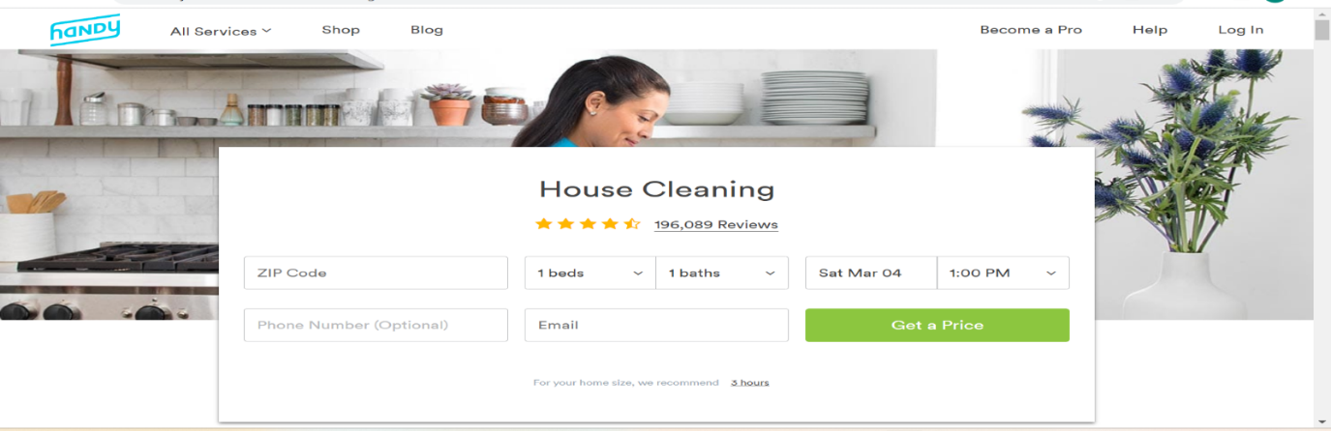

Figure ‑-Scheduling a Service with Handy

## System 2: Tidy

Tidy [5] is an online platform that connects customers with professional cleaners for various cleaning services, including home cleaning, office cleaning, and move-in/out cleaning. The platform allows users to easily schedule and manage their cleaning services online, with options for one-time or recurring cleanings, and the ability to customize their cleaning plans to fit their specific needs.

One of the main features of Tidy.com is their use of a rating system for their cleaning professionals, ensuring that customers have access to the highest quality cleaners. They also offer a satisfaction guarantee, which promises to address any concerns or issues with the cleaning service within 24 hours of the service.

However, one potential drawback of Tidy.com is their pricing structure, which can be on the higher end compared to other cleaning service providers. Additionally, some customers have reported issues with the quality of the cleaning service provided by Tidy.com, citing missed spots or incomplete cleanings One of the customers wrote: “The cleaner arrived as scheduled I met him and we discussed what was to be done When I got home, he had not even done half of what was on the list and they still charged me the full price No vacuuming, no dusting, the baths were not cleaned, and the list continues!” [6].

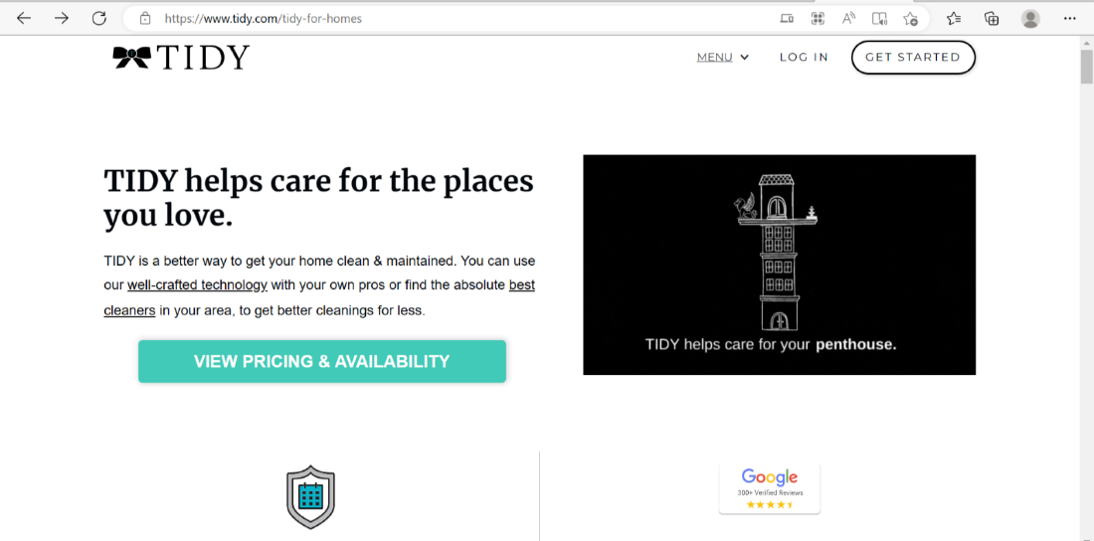

Figure ‑-Tidy Landing Page

## System 3: TaskRabbit

TaskRabbit [7] is an online and mobile marketplace that connects individuals with local service providers for a range of tasks, including cleaning. It provides users with a platform to find and book services and allows service providers to manage their work schedules.

While TaskRabbit is a popular and widely used platform for finding local service

providers, there are some drawbacks or limitations associated with certain features of the platform. One major drawback of TaskRabbit's official website is that the interface is not very user-friendly, which can make it difficult for users to navigate and find the services they need. This is particularly problematic for users who are not familiar with the platform or are not tech-savvy. Additionally, the website is not very responsive, which can lead to slow load times and a frustrating user experience. This drawback has been noted by several users and reviewers [8].

In addition, it has Limited scope of services; TaskRabbit offers a variety of services, but it is primarily focused on household tasks and errands, which may not be useful for those needing more specialized services. The following figure represents the home page of TaskRabbit website:

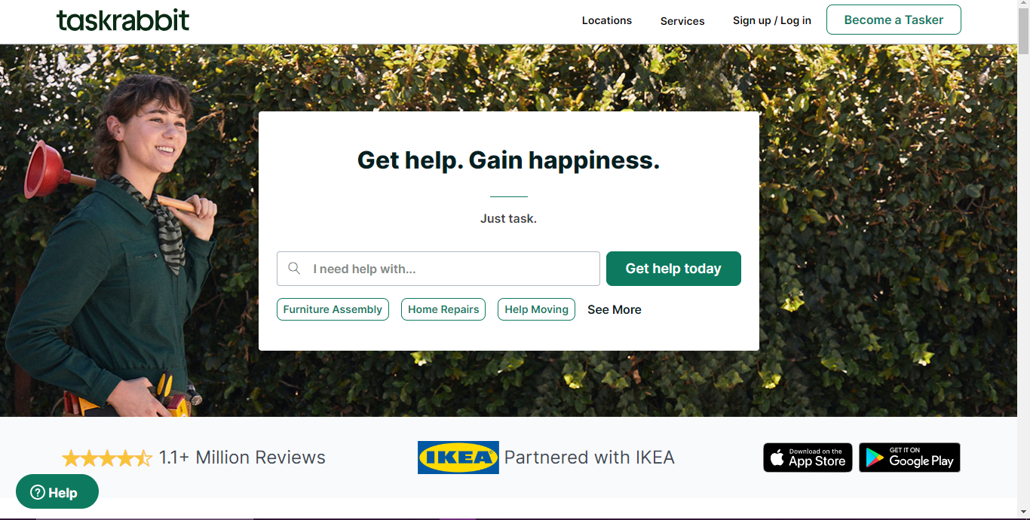

Figure ‑-TaskRabbit Home Page

## Systems Comparison

When comparing the systems based on their graphical user interfaces, Handy stands out for its excellent user interface and responsiveness. Tidy receives praise for its easy and effective navigation, while TaskRabbit is criticized for its lack of responsiveness. Additionally, Handy and Tidy both display simple and professional designs, whereas TaskRabbit falls short in this aspect. Moving on to the content and functionality of the systems, Handy is recognized for its well-structured content and the presence of a content management system. Tidy is commended for its usability and dynamic content, while TaskRabbit lacks these features.

Considering the features offered by each system, Handy impresses with its security measures and accessibility to content and location. Tidy is notable for its third-party integration capabilities and overall usability. On the other hand, TaskRabbit is appreciated for its security measures and registration form, but it falls behind in terms of third-party integration.

The following tables provide a comprehensive analysis of the distinctions between various factors. Table 2-1 focuses on the criteria of the graphical aspects, highlighting their variances. In Table 2-2, we delve into a deeper comparison based on content and functionality. Additionally, Table 2-3 explores a comparative analysis based on the features of the subject matter. Lastly, we present a comprehensive comparison table that assesses the divergences in graphical interfaces**.**

Table ‑:Comparison Table Based on Graphical Interfaces

|  |  |  |  |
| --- | --- | --- | --- |
| **Criterion 1** | **Handy** | **Tidy** | **TaskRabbit** |
| **Graphical Interface** |
| Good user interface | **✔** | **✔** | 🗶 |
| Easy and effective navigation | **✔** | **✔** | 🗶 |
| Simple and professional Design | **✔** | **✔** | 🗶 |
| Responsive | **✔** | **✔** | 🗶 |

Table ‑: Comparison Table Based on Content and Functionality

|  |  |  |  |
| --- | --- | --- | --- |
| **Criterion 2** | **Handy** | **Tidy** | **TaskRabbit** |
| **Content and Functionality** |
| Quality content structure | **✔** | **✔** | 🗶 |
| Usability | **✔** | **✔** | 🗶 |
| Dynamic content | **✔** | **✔** | 🗶 |
| Content management system | **✔** | **✔** | 🗶 |

Table ‑: Comparison Table Based on Features

|  |  |  |  |
| --- | --- | --- | --- |
| **Criterion 3** | **Handy** | **Tidy** | **TaskRabbit** |
| **Features** |
| Security measures | **✔** | **✔** | **✔** |
| Third party integration | **✔** | **✔** | **✔** |
| Accessible content and location | **✔** | **✔** | **✔** |
| Registration form | **✔** | **✔** | **✔** |
| Environmental awareness | 🗶 | 🗶 | 🗶 |

## Conclusion and Motivation

To address the drawbacks and limitations associated with existing cleaning service platforms, the newly proposed Clean Up platform should prioritize resolving these issues to deliver a seamless and satisfactory experience for customers. Notably, attention should be given to ensuring high-quality cleaning services at competitive prices, streamlining the booking process for users, and implementing a robust quality control system to guarantee customer satisfaction. By focusing on these areas, Clean Up will gain a competitive edge in the market and effectively cater to the growing demand for professional cleaning services.

All the comparable techniques and systems described are good. However, there is still room for improvement. This chapter provided a comprehensive survey of existing methods and similar systems in the field of cleaning services, including the strengths and weaknesses of current approaches and systems, and what features and functionalities are essential for a successful cleaning service platform. Handy, Tidy.com and TaskRabbit are online platforms that provide customers with cleaning services. All these platforms are certainly phenomenal advancements with several benefits ranging from their user interface to their content and features. What sets the cleanup system apart from the systems discussed in this chapter is its unique feature called "Environmental Awareness." This feature distinguishes it by promoting the use of eco-friendly cleaning products that are non-toxic, biodegradable, and free of harmful chemicals. Moreover, the platform encourages the use of water-efficient cleaning methods, which are not supported by other systems.

# System Design

## Introduction

This chapter provides an in-depth exploration of the system design methods employed in the development of the Clean Up system. It encompasses both technical and non-technical aspects, detailing how users will navigate and utilize the system's services while effectively responding to various use cases. Furthermore, the chapter encompasses a discussion on the financial viability and scope of the system, considering environmental awareness. Additionally, potential risks associated with the system's implementation and operation will be addressed. The design of the Clean Up system will be illustrated through various UML diagrams, providing a comprehensive understanding of the system's structure and functionality.

## Requirements and Specification Analysis

This section aims to demonstrate the integration of requirements and use cases in this project, resulting in an improved user experience and exceptional service quality for all system users, including patients, doctors, and administrators. By outlining the system's structure, specifications, and distinguishing features, this section provides clarity on the unique aspects of the system that set it apart from others. It enhances understanding by emphasizing user-friendliness and the commitment to delivering top-notch services.

### Functional Requirements

The Cleanup system implements the following operations and activities to ensure seamless functionality and enable users and companies to perform their intended actions effectively:

* Users should be able to register with the app using their email.
* Users must be able to securely log in to access the app's features.
* Users should be able to easily request to book a cleaning service by selecting the desired date, time, site, and type of cleaning required.
* The system must ensure proper scheduling and avoid conflicts in appointment timings.
* The app should provide users with a list of professional cleaning companies and individuals available in their area.
* Users must be able to browse and select the cleaning company or individual that suits their needs.
* Users should be able to make secure payments for the cleaning services through the app.
* The system should support various payment methods, such as credit/debit cards, PayPal, or cash.
* Users must have the ability to review and rate the services provided by cleaning companies.
* The system should store and display user reviews to help other users make informed decisions.
* Users should have the option to customize their cleaning plans based on their specific requirements.
* Providers can add offers and services, and view bookings and reviews. `
* An admin is available to manage the overall functionality of the app.
* The admin can remove cleaning companies, monitor users, and hand-manage payment transactions.

These functional requirements ensure that users can efficiently register, book cleaning services, select companies, make payments, provide feedback, customize their cleaning plans, and enable cleaning companies to manage their operations seamlessly. Additionally, the admin panel empowers the app administrators to oversee and control the app's overall functionality and resolve any issues that may arise.

### Use Case Diagrams

In this section, we will present the use case diagrams for the system, illustrating the actors that interact with the system and the fundamental flow of system behavior. The use case diagrams will cover the following actors: Users (All), Clients, Providers, and Admins. We will also outline the actions that each of these actors can perform to provide a comprehensive understanding of their roles within the system.

* **Users Domain:**

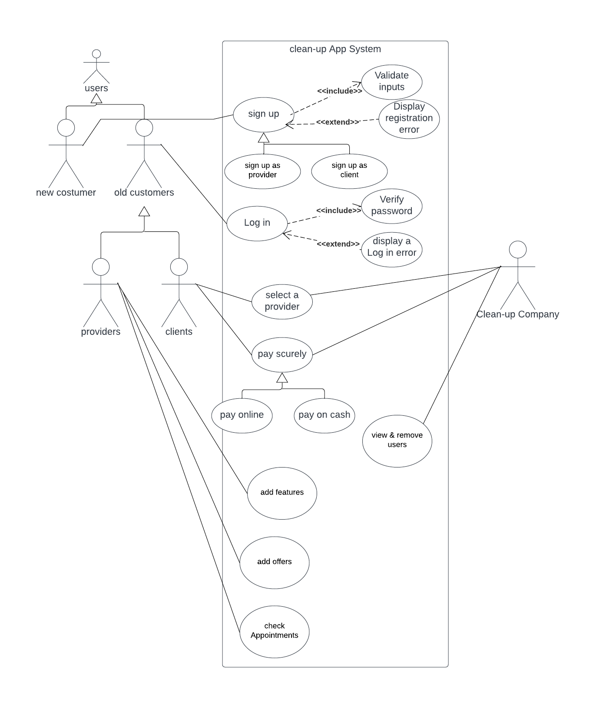

Figure ‑-User Use Case Diagram

**User Narrative identification:** Narrative identification of the use case for general users of the Clean-up platform is demonstrated in the table below.

Table ‑: User Use Case Narrative Table

|  |  |
| --- | --- |
| **Use Case ID** | 01 |
| **Use Case Name** | Register |
| **Primary actors** | New User |
| **Secondary actors** | Admin |
| **Purpose** | To create an account at the Clean-up platform and /or to be a company or individual cleaner in the application or a client for several cleaners in the application. |
| **Pre-condition** | New users must enter valid registration data. |
| **Postcondition** | If successful, a user account is created.  If the services of a company and reviews from customers are then the admin can delete the cleaner’s account. |
| **Events and steps** | New users enter all the required personal information.  He/she can choose to register as a cleaner or customer.  If all info is valid, a new account is created, and/or a new cleaner (individual or company) or customer is registered and saved in the database then the user can log into the application |
| **Exceptions** | Email has already been taken.  Invalid inputs are entered. |
| **Additional remarks** | None |
| **Conclusion** | With this simple registration interface, any cleaning company or individual cleaners in the country can have an account on our platform without any limitations except for professionalism. In addition, any individual can be a customer for any cleaner without any limitations. |

* **Clients Use Case Diagram**

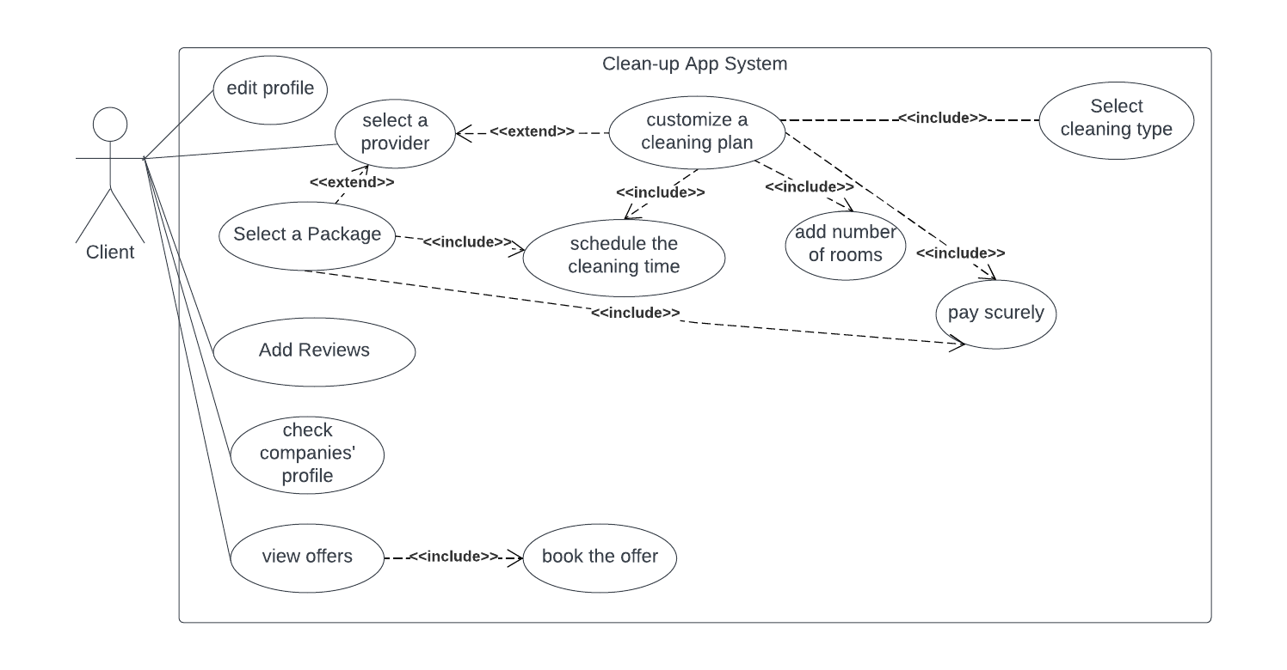

Figure ‑-Client Use Case Diagram

**Client Narrative identification:** Narrative identification of the use case for registered customers of the Clean-up platform is demonstrated in the table below.

Table ‑: Client Use Case Narrative Table

|  |  |
| --- | --- |
| **Use Case ID** | 02 |
| **Use Case Name** | Request Booking |
| **Primary actors** | Client |
| **Secondary actors** | None |
| **Purpose** | To request a booking appointment with any cleaner or cleaning company by customizing their cleaning booking. |
| **Pre-condition** | Clients must be logged into their accounts in the system.  The client must choose a site for cleaning. |
| **Post condition** | If successful, the request will be added to the cleaner’s request list so the client can wait for the time of the scheduled booking to be completed. |
| **Events and steps** | The client adds a site to request a booking to clean it.  The client chooses from the list the preferred cleaner or company.  After picking the client can customize the cleaning service hen request the booking.  The request will be added to the request lists on the cleaner side.  When the service is completed, the client can add a review and this review can be seen by other users in the app. |
| **Exceptions** | Client is not logged in. |
| **Additional remarks** | Time scheduling is important when requesting a booking. |
| **Conclusion** | This use case’s smoothness and user-friendly experience allows anyone to have access to a professional cleaning service in a quick and convenient manner, it also simplifies the clients that need cleaning services to have scheduled cleaning booking services. |

* **Providers Use Case Diagram**

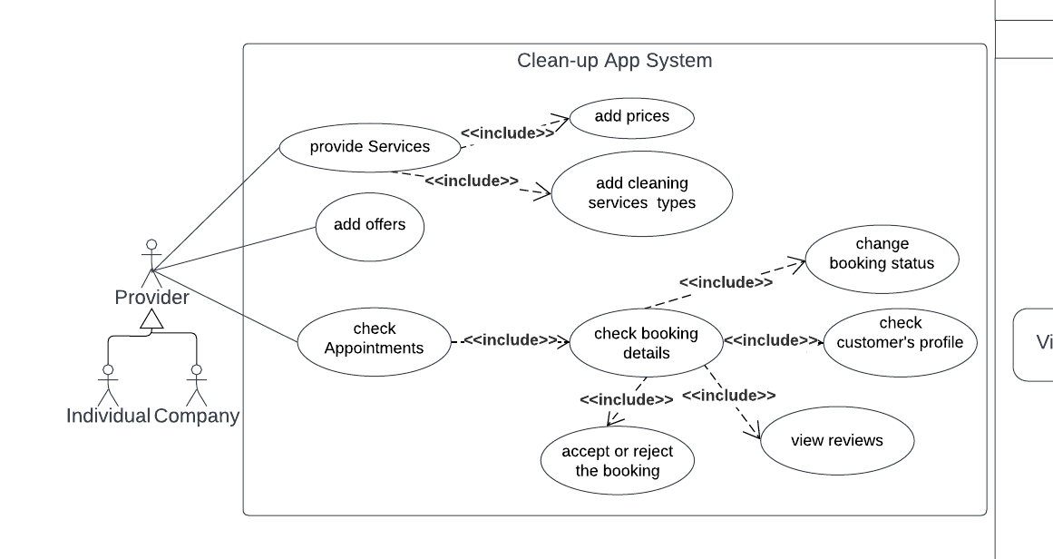

Figure ‑-Provider Use Case Diagram

**Provider Narrative identification:** Narrative identification of the use case for registered providers of the Clean-up platform is demonstrated in the table below.

Table ‑: Provider Use Case Narrative Table

|  |  |
| --- | --- |
| **Use Case ID** | 03 |
| **Use Case Name** | Check bookings and adding Features |
| **Primary actors** | Provider |
| **Secondary actors** | None |
| **Purpose** | To check booking requests, add services to be shown for the customers and add offers. |
| **Pre-condition** | Provider must be logged in their account in the system. |
| **Post condition** | If successful, the provider can respond to clients’ requests and added offers, and other features will be added to the database and shown to users. |
| **Events and steps** | The provider logs into their account.  The provider can add offers which will be shown to the clients and edit the database, check the request lists from various clients, if any request is done the status will be updated to completed.  Check the client’s reviews on any service provided by them.  provide more services that can be done by adding new services through the field in their profile which will update the database of the provider.  Edit their profile personal information which will be updated in the database. |
| **Exceptions** | The provider is not logged in. |
| **Additional remarks** | The provider should show their free time to the clients to request a correct booking appointment. |
| **Conclusion** | This use case’s smooth and user-friendly experience allows anyone to have access to a professional cleaning service quickly and conveniently, it also simplifies the cleaners’ tasks by collecting the choices of each client easily before the booking appointment. |

* **Admin Use Case Diagram**

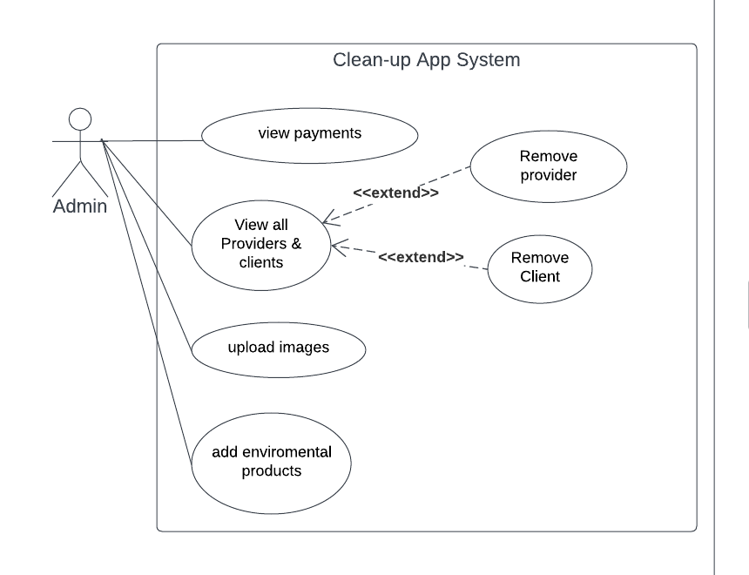

Figure ‑-Admin Use Case Diagram

**Admin Narrative identification:** Narrative identification of the use case for registered admins of the Clean-up platform is demonstrated in the table below.

Table ‑: Admin Use Case Narrative Table

|  |  |
| --- | --- |
| **Use Case ID** | 04 |
| **Use Case Name** | View all providers and clients. |
| **Primary actors** | Admin |
| **Secondary actors** | None |
| **Purpose** | Allow admins to manage entities of the system by removing a provider of the client. |
| **Pre-condition** | Admin must be logged in to their account in the system |
| **Postcondition** | If successful, the provider can respond to clients’ requests and add offers, and other features will be added to the database and shown to users. |
| **Events and steps** | The admin logs into the account.  The admin check who are the users in this application (companies, individual cleaners & clients)  The admin checks the reviews of the company or individual cleaners in case of negative reviews the admin can take severe actions and remove the cleaner.  The admin checks if any client wrote any offensive words in their reviews and removes them. |
| **Exceptions** | The provider is not logged in. |
| **Additional remarks** | none |
| **Conclusion** | This use case gives the admins’ system full control over the application. It ensures flexibility and personalization of the system which makes it more convenient to manage. |

## System Architecture

The system architecture for the cleanup app consists of a three-tier architecture with two front-end layers: one layer for handling the user interface, another one the admin-side layer for business logic and data processing, and a database layer for storing and managing data.

Here is a breakdown of each layer:

* Front-end layer (Admin/Client side): This layer will be responsible for handling the graphical user interface (GUI) and user admin functionality. It will include both a client-side and an admin-side component. The client-side component will be used by individuals and companies to book and manage cleaning services, while the admin-side component will be used by professional cleaners to manage their cleaning schedules and services. The client-side section enables the app's users to explore various activities and services, as well as interact with forms and buttons to input and request data. The app is accessible through smart devices and automatically adjusts to fit different screen sizes. Users can provide inputs and make requests, which are then sent to the server through requests for processing in the backend.
* The backend (Server-side):

This layer will manage the business logic and data processing for the app. It will include a web server that communicates with the front-end layer, as well as a file server for storing data and a database server for storing customer and cleaner information. During the development of Clean Up, the MVC (Model-View-Controller) pattern was utilized. This pattern separates the application into three main components: models, UI (user interface), and adapters. The models are responsible for managing the data and business logic of the application. They manage tasks such as data retrieval, storage, and manipulation. The UI component focuses on presenting the information to the users and capturing their input. It consists of various visual elements, such as screens, forms, and buttons, which allow users to interact with the application. Adapters function as intermediaries between the models and the UI. They facilitate communication between these two components, ensuring that data flows smoothly in both directions. Adapters are responsible for converting the data from the models into a format suitable for display in the UI, and vice versa. By employing the MVC pattern, the development process of Clean Up was organized and structured, promoting modularity, reusability, and separation of concerns.

Additionally, in the Clean Up project, all Java classes have been organized into various packages to ensure better structure and maintainability. Here are some of the packages used:

* Enumerations Package: This package contains classes that define different payment methods. Enumerations are typically used to represent a fixed set of values such as the type of payments (debit, visa card, PayPal, or cash).
* File Upload Package: The classes in this package handle image uploading functionality. They provide methods and utilities to manage the uploading process and handle file-related operations.
* Fragments Package: This package contains classes representing various fragments in the application. Fragments are reusable UI components that can be combined to create different screens or sections of the app.
* Interface Fragment Refresh Package: This package includes interfaces related to fragment refreshing. These interfaces define methods that allow fragments to communicate and update their content or perform specific actions.
* Utilities Package: The classes in this package provide utility functions and helper methods for configuration settings, retrieving IP addresses, getting image paths, and managing other data-related operations.
* Admin Package: at encompasses all functionality and components relevant to the administration of the application. This package contains classes and modules that manage administrative tasks and privileges.

By organizing classes into different packages based on their functionality, the project's codebase becomes more organized, modular, and easier to navigate. This approach helps improve code reusability, maintainability, and scalability.

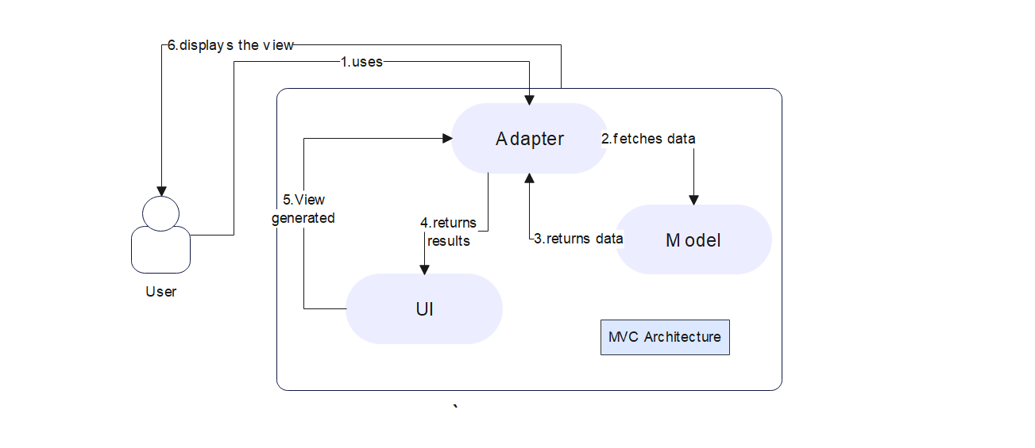

Figure ‑-MVC Architecture

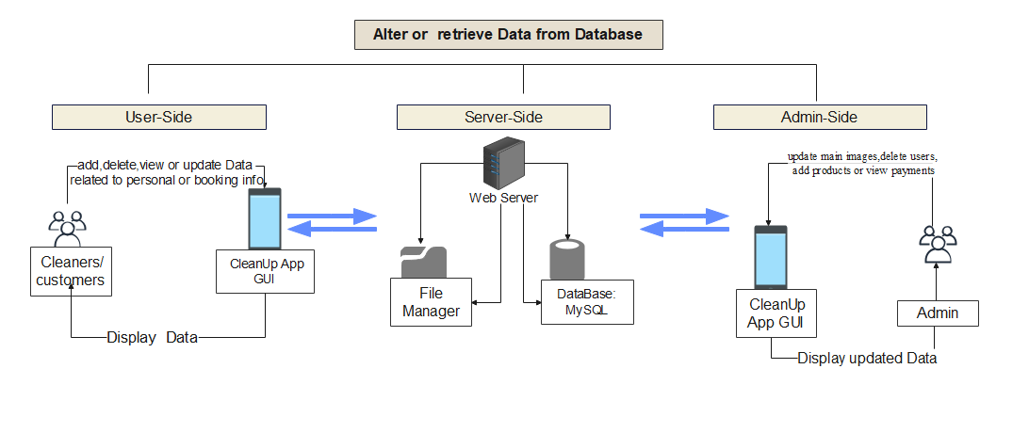

Figure ‑-Cleanup System Architecture

## Class Diagrams

In this section, we will present a UML Class Diagram that illustrates the fundamental structure of the system. The diagram serves as a visual representation of the relationships between the various entities or classes within the application. By depicting these relationships, the diagram highlights how the entities interact and depend on one another. Developing a class diagram is a crucial step in system design, as it provides a blueprint for organizing and implementing the project effectively. It allows for a clear understanding of the system's hierarchy and aids in creating a well-organized and efficient design before moving on to the implementation phase.

The depicted class diagram [9] provides an overview of all the classes present in the system. It illustrates their respective attributes, operations (methods), and relationships with other objects. One crucial aspect to highlight is that every model within our system is required to extend the AppCompatClass. This inheritance ensures effective communication with the database, facilitating seamless data management. Additionally, the User model specifically must implement the Interface. This implementation enables the User model to manage identity-related information within the system. The relationship between the models, the controllers, and the search models integrated in the MVC architecture used in the Clean Up system is demonstrated below.

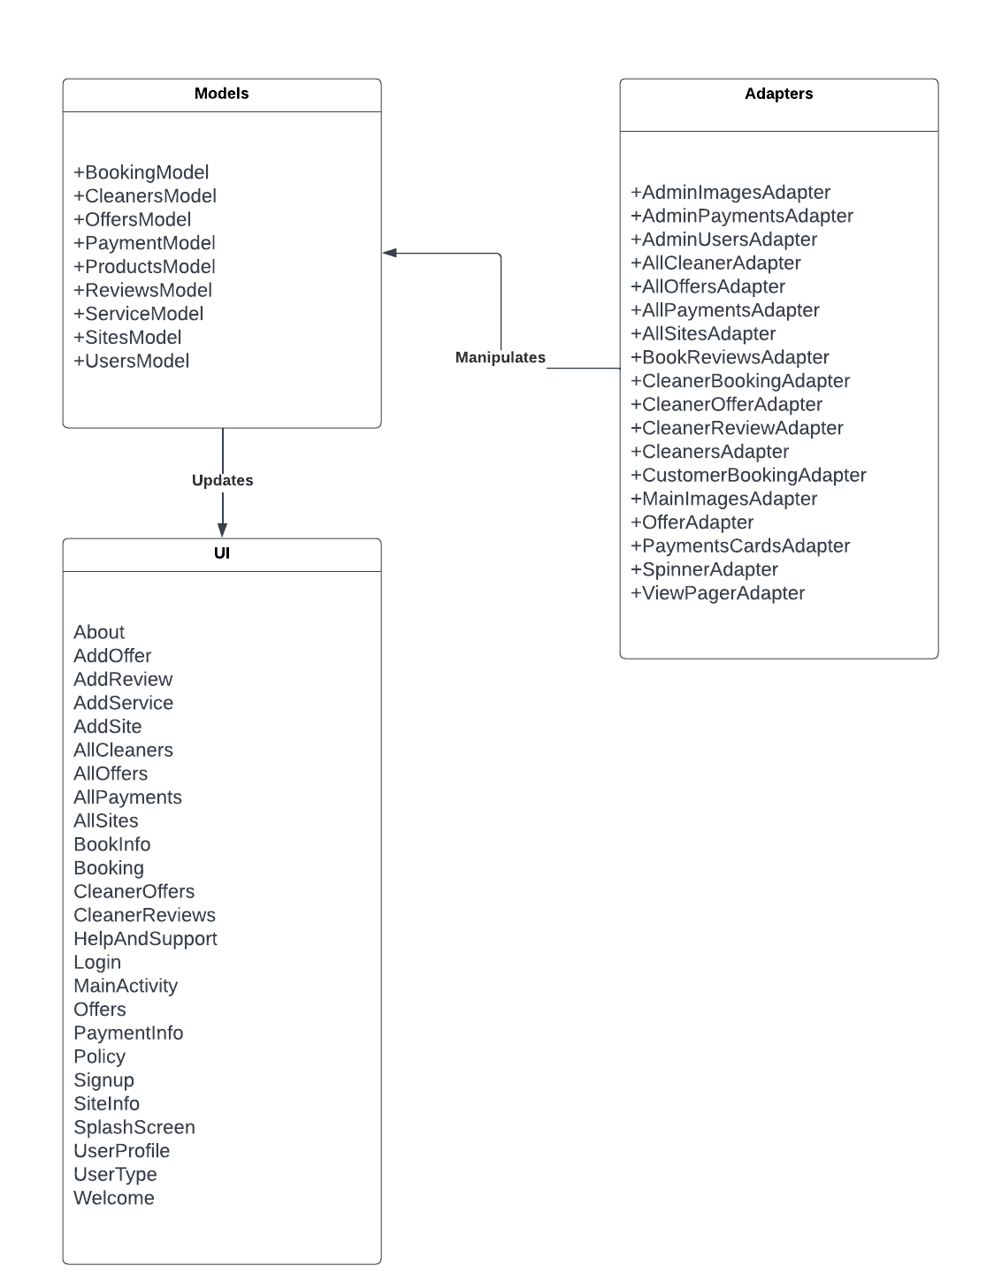

Figure ‑-MVC Class Diagram

## Sequence Diagrams

Sequence diagrams are a type of UML diagram that illustrate how objects within a system perform multiple operations to interact with each other. These diagrams can be seen as a type of collaboration among the system's classes. The sequence diagrams shown in the figures below are useful for both technical and non-technical readers to fully understand the main application scenarios for each of the system's users, including general users who can log in and register (Figure 11), service providers (Figure 12), customers (Figure 13), and admins (Figure 14).

All these diagrams explain how each operation is performed sequentially from start to finish. These diagrams are important to visualize since they provide a clear understanding of the logic underlying the system's main operations.

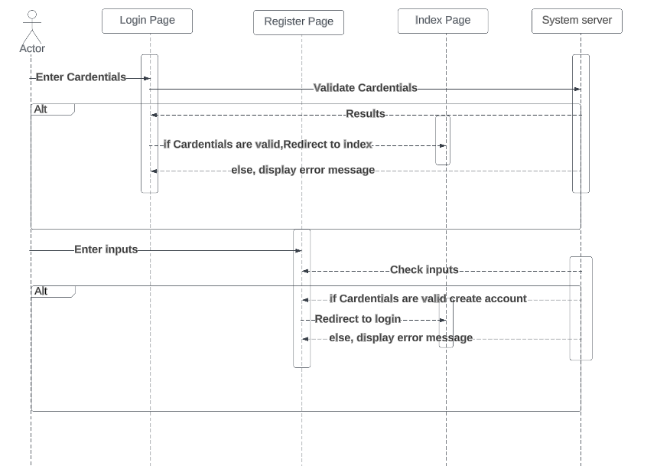

Figure ‑-Login/Registration Sequence Diagram

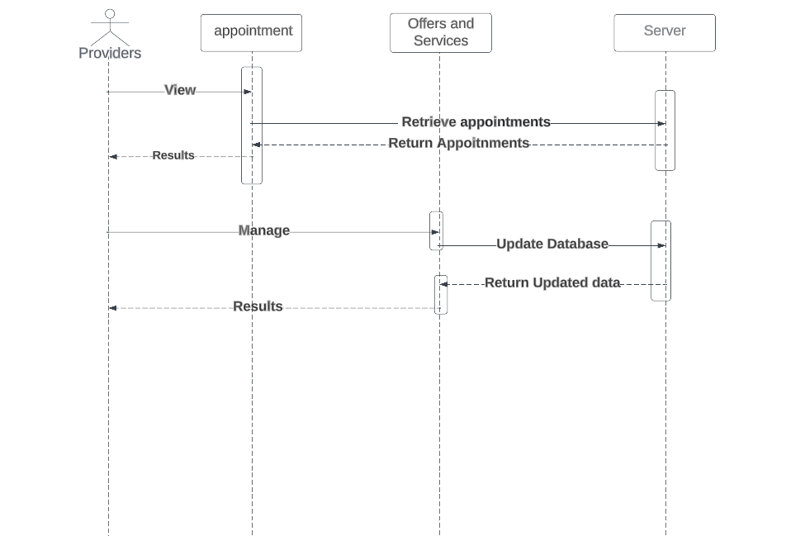

Figure ‑-Cleaning Services Providers Sequence Diagram

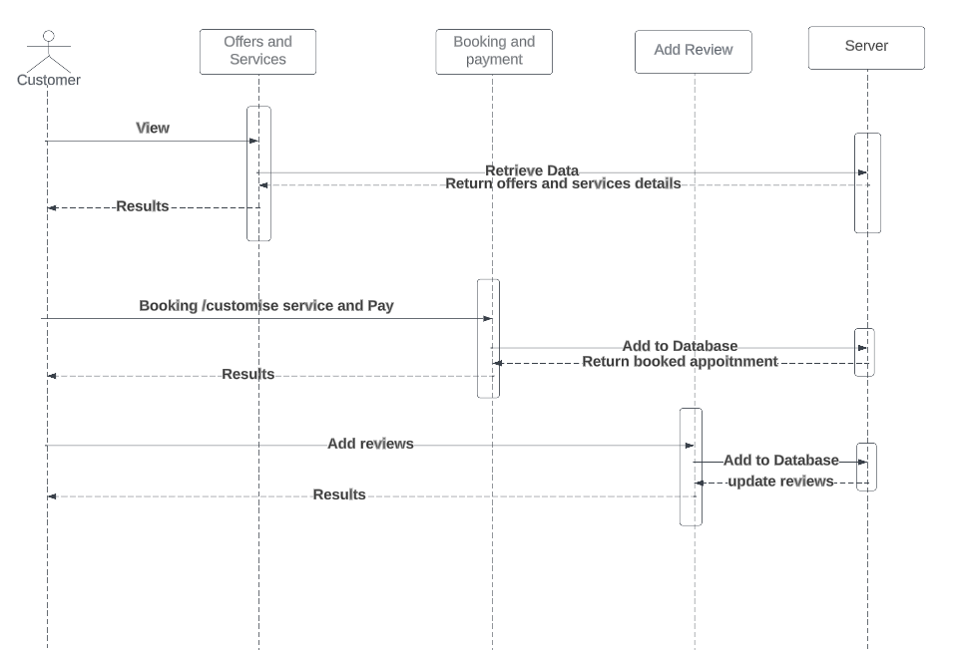

Figure ‑-Customer Sequence Diagram

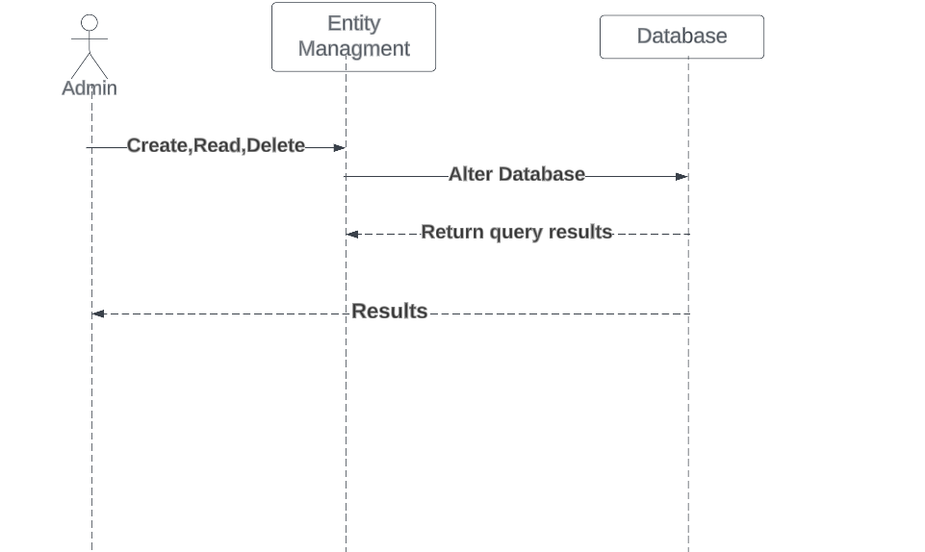

Figure ‑-Admin Sequence Diagram

## Activity Diagrams

Activity diagrams are a type of behavioral diagram in UML (Unified Modeling Language) that depicts the flow of activities and actions within a system or process. They illustrate the sequence of actions, decisions, and control flows involved in the execution of a particular behavior.

The role of activity diagrams is to provide a visual representation of complex workflows or business processes, enabling stakeholders to understand and analyze the behavior of a system. The Activity diagrams shown in the figures below are useful for both technical and non-technical readers to fully understand the main application scenarios for each of the system's users.

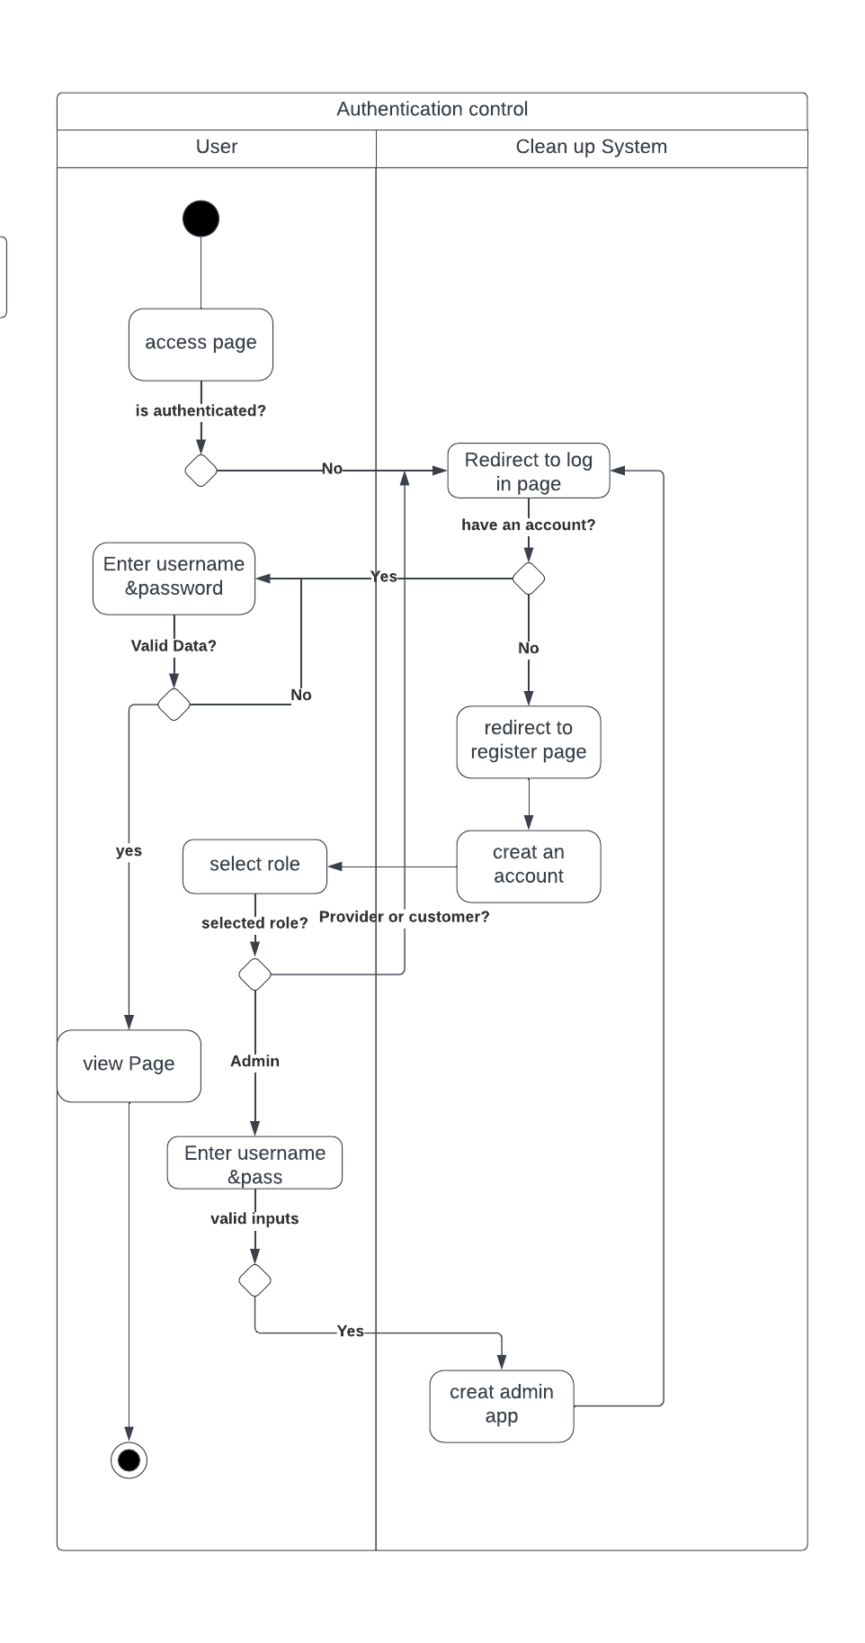

Figure ‑-Authentication and Access Control Activity Diagram

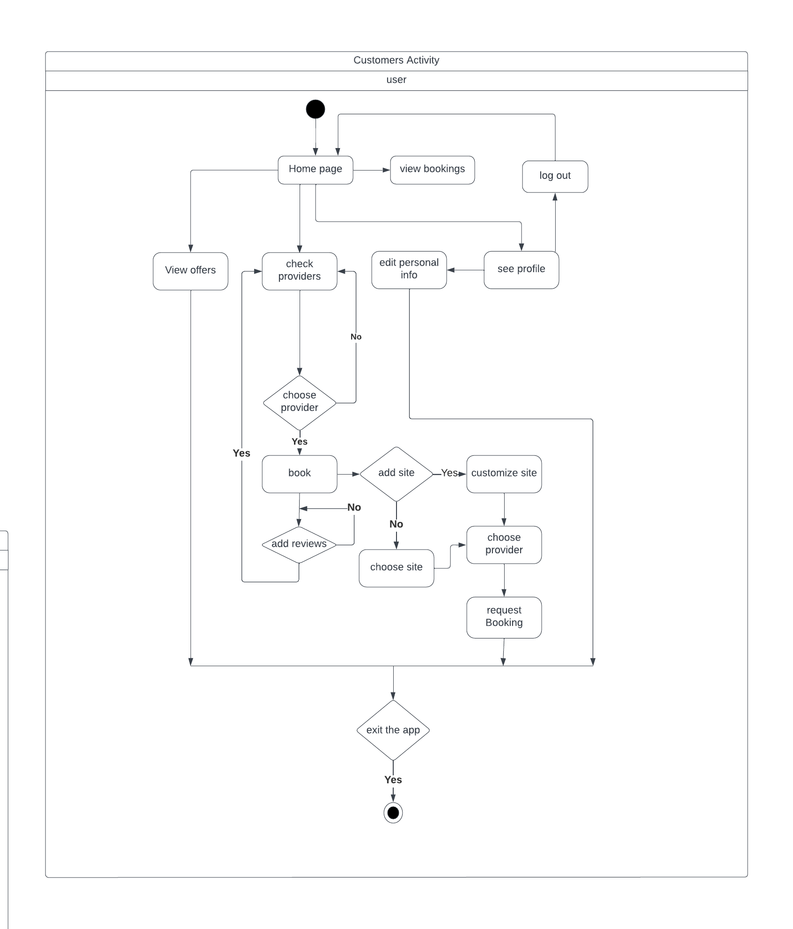

Figure ‑-Customers Activity Diagram

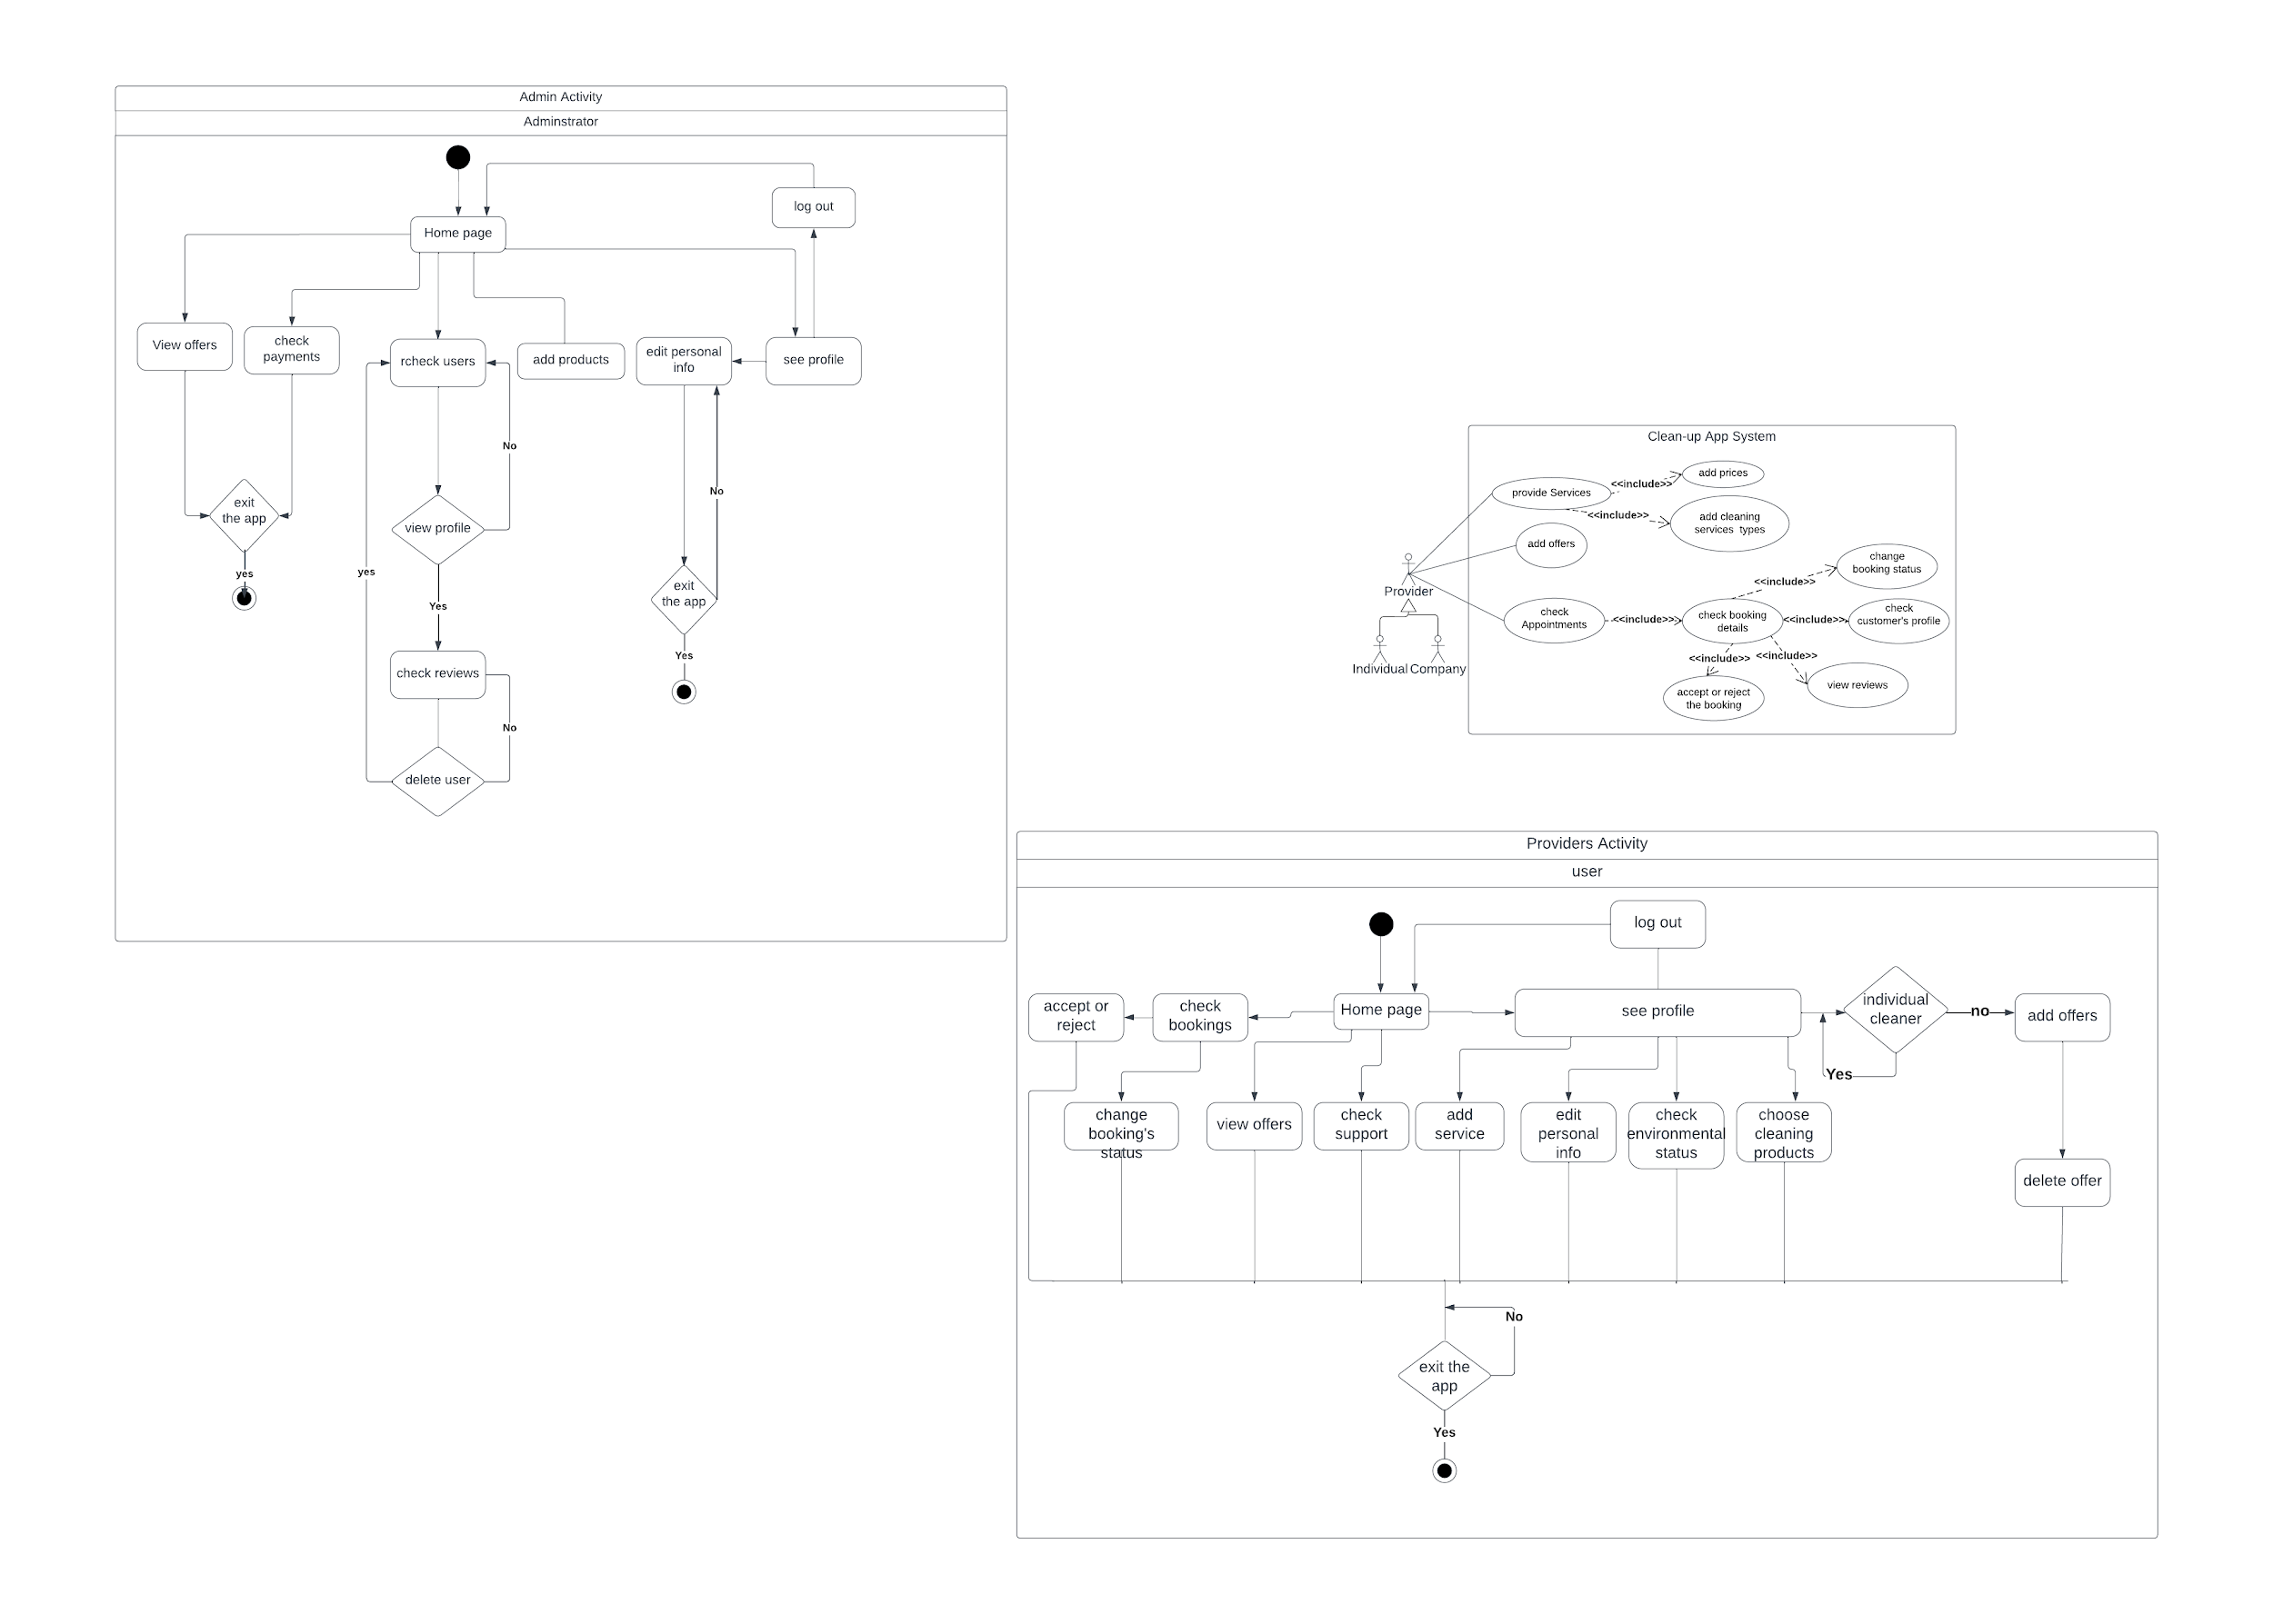

Figure ‑-Provider’s Activity Diagram

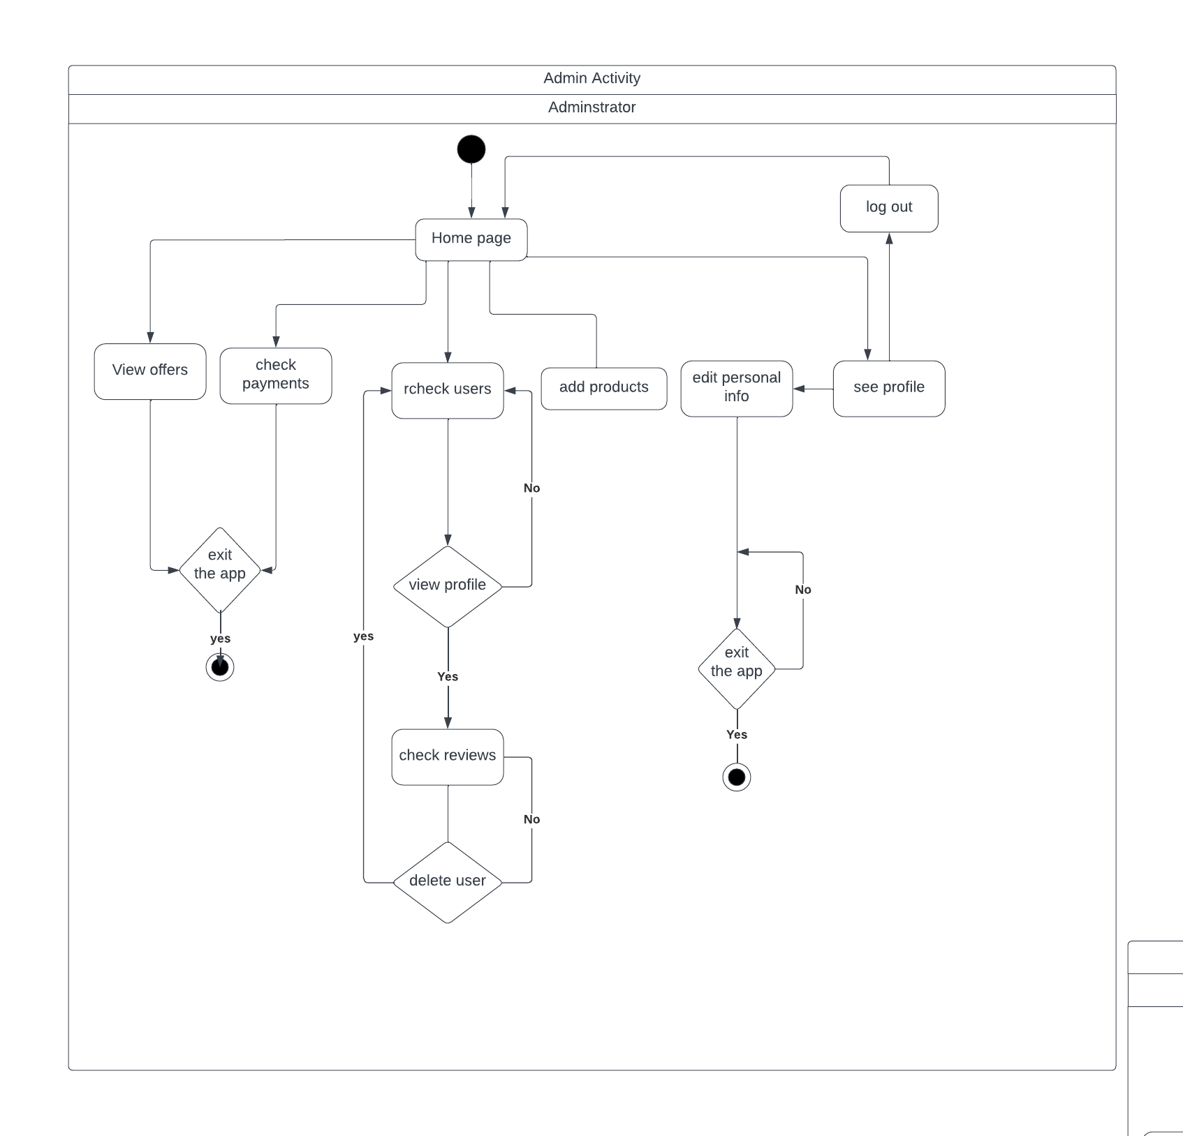

Figure ‑-Admin’s Activity Diagram

## Entity-Relationship (ER) Diagrams

An entity relationship diagram (ERD) is a graphical representation of entities and their relationships to each other.

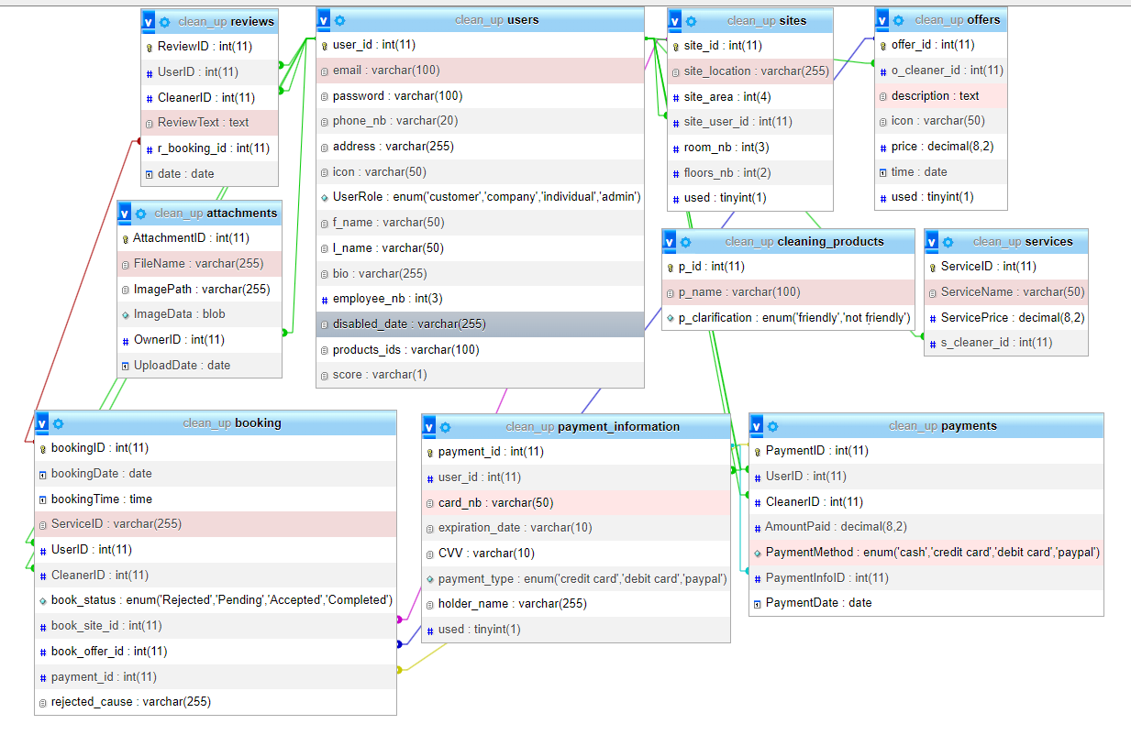

Figure ‑-ER Diagram

* A User can have multiple Bookings, and each Booking belongs to a single User.
* A Cleaner can have multiple Bookings, and each Booking belongs to a single Cleaner.
* A Cleaner can offer multiple Services, and each Service can be offered by multiple Cleaners. This is a many-to-many relationship.
* A company can have multiple Offers, and each Offer belongs to a single company.
* A Cleaner can have multiple Reviews, and each Review belongs to a single Cleaner.
* A User can write multiple Reviews, and each Review is written by a single User.
* A Payment can be made by a single User, and a User can make multiple Payments.
* A Payment can be received by a single Cleaner, and a Cleaner can receive multiple Payments.
* A Payment can be associated with a single Service, and a Service can be associated with multiple Payments.
* A Booking can be associated with a single Payment, and a Payment can be associated with multiple Bookings.
* A user can have multiple sites and each site refers to a single user.
* Each booking is associated with a single site.

## Methodology

The system design phase involves creating a detailed plan for the app's functionality, defining its architecture and components, and determining their interactions. This step is crucial for avoiding costly rework and ensuring the app's flexibility and maintainability. Once the system design is established, creating a stable and well-designed database becomes a priority, providing a solid foundation for data storage and retrieval. With the database in place, the focus shifts to designing each screen, including wireframes and user interface layout, tailored around the app's data requirements. Throughout the development process, it is important to update UML diagrams to reflect any changes to the system design, ensuring that the code implementation aligns with the project's objectives. Finally, the implementation of Java and XML code can commence, following a methodology that emphasizes modularity, organization, and ease of maintenance.

## Non-Technical Aspects

### Financial Viability

From a financial perspective, the Cleanup System is an advantageous venture. As a software-based project, there is no need for expensive hardware, which reduces overall development costs. Additionally, the services required to create and host the app are minimal. This is further compounded by the fact that all services provided by the system can be conducted remotely, thereby reducing operational costs.

To evaluate the potential financial viability of the Cleanup System, a cost-benefit analysis has been conducted (as shown in Table ‎2). The analysis assumes that the minimum service price is $30, of which the cleaning company receives 85%, while the remaining 15% is retained by the application owner. It is also presumed that each cleaning company will have at least five appointments a day and that the platform will work with a minimum of ten cleaning companies. Furthermore, it is assumed that the system will operate for two hundred days (around six and a half months) per year.

Overall, this analysis indicates that the Cleanup System has the potential to generate a

significant revenue.

Table ‑: Cost-Benefit Analysis

|  |  |
| --- | --- |
| Item | Cost (Per Year) |
| Publishing on play store | -25$ |
| App Hosting | -90$ |
| SEO and Marketing | -3000$ |
| SSL (Secure Sockets Layer) Certificate | - $33 |
| Maintenance | -1200$ |
| Revenue from Appointments | +45,000$ |
| Total | 40,677$ |

### Stakeholders

There are several stakeholders who will benefit from the cleanup platform. Primarily, Individuals and companies in need of cleaning services: The Cleanup platform provides an easy-to-use platform for booking and managing high-quality cleaning services. This is beneficial for individuals who are looking for a reliable and affordable cleaning service, as well as for companies who may need cleaning services for their offices or facilities. Secondly, the cleanup platform has the potential to benefit local communities by supporting small businesses. As the platform grows, it may also attract more professional cleaners to the area, increasing competition and potentially driving down prices for customers. Finally, the cleanup platform may benefit the broader cleaning industry by promoting high-quality cleaning services and professional standards. By collaborating exclusively with professional cleaners who have been vetted and trained, the platform can help to establish a reputation for reliable and high-quality cleaning services. This can help to raise industry standards and promote best practices, benefiting all stakeholders in the cleaning industry. While the Cleanup platform has the potential to benefit many stakeholders, there are also some who may be negatively impacted by its implementation. The existing cleaning companies in the area where the platform is introduced who do not meet the platform's standards or who are unable to compete with the prices offered by other cleaners on the platform. These companies may experience a loss of business if customers choose to use the cleanup platform companies instead of their services. It is important to recognize and address these potential harms to ensure that the cleanup platform is developed in a way that is fair and equitable to all stakeholders.

To ensure that the cleanup platform is developed in a way that meets the needs and interests of all stakeholders, it is important to engage a variety of voices in the project's planning and implementation. There are several groups that should have a say in how the project works:

1. Customers: Customers who use the Cleanup platform will be one of the most important stakeholder groups, as they will be the ones using the platform to book and manage cleaning services. It is important to solicit feedback from customers throughout the development process to ensure that the platform meets their needs and expectations.
2. Professional cleaners: Professional cleaners are another key stakeholder group that should have a say in how the platform works. By working directly with cleaners to understand their needs and concerns, the platform can be developed in a way that supports and empowers cleaners.
3. Existing cleaning companies: As mentioned earlier, existing cleaning companies in the area where the platform is introduced may be negatively impacted by its implementation. It is important to engage with these companies to understand their concerns and work with them to develop solutions that support their continued viability.
4. Local communities: The Cleanup platform may have a broader impact on the local community, particularly in terms of supporting small businesses and creating job opportunities. It is important to engage with local community groups and leaders to understand their perspectives and ensure that the platform aligns with local priorities.
5. Regulators and policymakers: Depending on the regulatory environment in the area where the platform is introduced, regulators and policymakers may also need to have a say in how the project works. It is important to understand any relevant laws and regulations and work with local authorities to ensure that the platform operates in compliance with applicable rules and standards.

By engaging with a broad range of stakeholders throughout the project's development and implementation, the cleanup platform can be developed in a way that maximizes benefits and minimizes negative impacts for all involved.

### Scope

The clean-up platform project includes a range of services to ensure a clean and organized space. This may involve dusting and wiping down surfaces, vacuuming and mopping floors, cleaning bathrooms and kitchens, emptying trash and recycling bins, washing windows and mirrors, deep cleaning of carpets or upholstery, organization, and decluttering services, and even laundry and ironing services. The project could also include partnering with local organizations and charities to provide cleaning supplies and support to those in need that affected by the economic crisis and political instability in Lebanon.

However, there are certain services that may not be included in the scope of the project, such as heavy-duty outdoor cleaning or landscaping, hazardous waste removal, structural repairs or renovations, pest control services, or moving heavy furniture or appliances.

### Risks

One of the biggest risks is the lack of trust that users may have on the platform, or the cleaners hired through it. This could be due to negative reviews or news stories about fraudulent cleaning companies, which could lead to a loss of business. Quality issues also pose a risk, as the cleaning services provided on the platform may not meet the expected quality standards, leading to complaints and negative reviews. Safety concerns arise when cleaning services involve the use of hazardous materials, which could lead to health problems and legal liabilities. Data security is also a risk, as personal information collected from users and cleaners must be protected from theft or misuse. Competition from other platforms or companies offering similar services could make it difficult for the platform to attract and retain customers. Legal and regulatory compliance is also important, as the platform must comply with employment laws, tax regulations, and consumer protection laws. Failure to comply could lead to legal liabilities and damage to the platform's reputation. Finally, technological issues, such as downtime or payment processing errors, could lead to user frustration and loss of business.

Another risk that should be considered in the clean-up platform project is the privacy of the houses being cleaned. After entering people's homes, the cleaners could potentially have access to sensitive personal information or valuable possessions, which could lead to theft, misuse, or other privacy violations. The platform should implement robust privacy policies and security measures to ensure that personal information and property are protected and should conduct background checks and training for all cleaners to ensure their trustworthiness and professionalism. Failure to address privacy concerns could result in legal liabilities and loss of trust from customers, which could harm the platform's reputation and success. These risks must be addressed to ensure the success of the clean-up platform.

### Schedule and Milestones

Schedule and milestones of the project depicts the many jobs that will be done in this system, along with their time length.

Table ‑: Schedule and Milestones of the Project

|  |  |  |  |
| --- | --- | --- | --- |
| **Task Name** | **Start** | **Finish** | **Weeks** |
| Defining the Project | Feb 20 | Feb 23 | 1 |
| Pre-Development | | | |
| Project overview | Feb 26 | Feb 28 | 2-3 |
| Initial Draft | Feb 28 | March 21 | 3-4 |
| Designing UML Diagram | March 22 | March 31 | 4-6 |
| Pre-Development | | | |
| Setting up the  database | April 1 | April 7 | 6-7 |
| Designing App on Figma | April 8 | April 15 | 7-8 |
| Development | | | |
| Application Development | April 16 | May 18 | 8-13 |
| Post-Development | | | |
| Testing and final changes | May 18 | May 25 | 14-15 |

### Ethical and Social Considerations

It is important to carefully consider several ethical issues when developing the cleanup platform. One key consideration is the protection of private user data. The platform must ensure that user data is stored securely and is only accessed by the user and the cleaning company they are working with for booking purposes. Additionally, the handling of payment information must also be carefully considered to maintain the privacy of users and adhere to ethical standards. The platform must ensure that all payment information is managed securely and appropriately to maintain the privacy of its users. By addressing these ethical issues, the cleanup platform can establish a reputation for responsible and ethical operation, building trust with users and promoting the platform's success.

### Environmental and Sustainability Considerations

The cleaning industry can have a significant environmental impact. Traditional cleaning products often contain harsh chemicals that can harm human health and the environment. The Cleanup platform encourages the use of eco-friendly cleaning products that are non-toxic, biodegradable, and free of harmful chemicals. This can reduce the overall environmental impact of cleaning services while also promoting healthier living and working spaces.

### Relevant Standards

1. Mobile Application Testing and Verification (IEEE 829) - This standard provides guidelines for testing and verifying mobile applications, including functional testing, performance testing, and security testing.
2. User Interface Design for Mobile Devices (ISO 9241-110) - This standard provides guidelines for designing effective and usable user interfaces for mobile devices, including layout, typography, and navigation.
3. Apache: which is an open-source cross-platform web server software that is licensed under the Apache License 2.0.
4. Wi-Fi: which is based on the IEEE 802.11 standard. It is a wireless networking.

technology that connects devices to the internet via a wireless router.

1. JSON: which is a standard data exchange format that uses human-readable

language to store and transport data objects as attributes–value pairs and arrays.

## Conclusion

Overall, the design phase of the clean-up platform project has been thoroughly planned and analyzed in this report. The requirements and specifications were carefully considered and translated into functional system architecture, class diagrams, sequence diagrams, and activity diagrams. The non-technical aspects, such as financial viability, stakeholders, scope, risks, schedule and milestones, ethical and social considerations, and environmental and sustainability considerations, were also considered to ensure the success and sustainability of the platform. However, it is important to note that the implementation and execution phase will require close monitoring and adjustments to mitigate any unforeseen challenges or issues that may arise. By addressing these risks and ensuring the platform meets the needs and expectations of users and cleaners, the clean-up platform has the potential to be a valuable tool in connecting companies and individuals with professional cleaning services.

# Implementation/Simulation and Testing

## Introduction

In this chapter, we will delve into the implementation phase of the Cleaning Up application. We will provide an overview of the tools used to achieve the system's final functionality, along with a detailed description of how the backend and frontend components were developed and integrated to bring this idea into reality. We will explore the backend and frontend of the application, and highlight the steps taken to ensure seamless integration between these components. This chapter will shed light on the implementation journey of the Cleaning Up application, from development to finish.

## Implementation Tools

* Languages:

We chose to use Java, XML, PHP, and MySQL for the implementation of the Cleaning Up application for several reasons:

1. Familiarity: Our team is well-versed in these languages, which allows us to leverage our existing expertise and knowledge to efficiently develop the application. This familiarity helps streamline the development process and reduces the learning curve, allowing us to deliver a high-quality product in a timely manner.
2. Platform Suitability: Java is a popular and widely used programming language for Android app development, making it a natural choice for developing an Android application like Cleaning Up. XML is a markup language that is commonly used for defining the user interface layout in Android apps. PHP is a server-side scripting language that is well-suited for web-based applications, such as the backend of the Cleaning Up app. MySQL is a widely used and reliable database management system that is compatible with PHP, making it a suitable choice for storing and retrieving data in the application.
3. Ecosystem and Libraries: Java, XML, PHP, and MySQL have extensive ecosystems of libraries, frameworks, and tools that provide a wealth of resources and support for development. These resources facilitate the implementation process by offering pre-built solutions, documentation, and community support, which can accelerate development and help us deliver a robust and feature-rich application.
4. Industry Standards: Java, XML, PHP, and MySQL are widely recognized and adopted languages in the software development industry. They have a proven record of being used in numerous successful applications and have a large developer community, which ensures their stability, reliability, and future support.

Considering these factors, we chose Java for Android app development, XML for defining the user interface, PHP for server-side scripting, and MySQL for database management in the implementation of the Cleaning Up application. These languages offer a familiar and efficient development environment, are well-suited for the requirements of the application, and adhere to industry standards.

* Application Design:

-Figma: It is a cloud-based design tool that offers collaborative design, prototyping and interaction design, design components, and style guides, developer-friendly handoff, and extensibility. It allows multiple designers to collaborate in real-time, store design files securely in the cloud, create interactive prototypes, reuse design components, generate design specs and code snippets, and integrate with other design and development tools. Figma can streamline the UI/UX design process, promote consistency, accuracy, and collaboration among designers and developers, and result in a more efficient and effective design workflow for our project.

UI/UX: design in our project is crucial for several reasons. It enhances user engagement, improves usability, establishes branding and differentiation, reduces errors and increases efficiency, and allows for user feedback and iterative improvement. A well-designed UI/UX can impact the success of our application by creating a positive user experience, increasing user satisfaction, and promoting user adoption and loyalty.

* Database:

-Xampp: furnishes a suitable environment to test and verify the working of projects

based on Apache, Perl, MySQL database, and PHP through the system of the host

itself.

- MySQL Database: it is the main and only local database used in our system,

storing all the information about users, appointments, and other entities.

* Android Studio:

-Integrated Development Environment (IDE) for Android app development. Android Studio provides the fastest tools for building apps on every Android device, a Flexible built system, Intelligent code editor.

-Android Studio has a valuable API feature that lets developers preview their app's user interface (UI) in real-time on multiple devices with different configurations, helping them create responsive UI designs. Wear OS Pairing, on the other hand, is a feature in Android Studio that allows developers to evaluate and debug their apps on physical Wear OS devices, ensuring that their app works correctly on wearable devices like smartwatches. Both features are helpful in developing apps for different devices and form factors, including wearables running on Wear OS.

## Implementation Summary

In this chapter, we will discuss the implementation of the cleanup application presenting its designs and functionalities. The implementation of the cleanup app follows a three-tier architecture with two front-end layers and a database layer. This architecture was discussed in Chapter 3, specifically in Section 3.3, which focuses on the system design and architecture.

The front-end layer consists of a client-side component for users to access the app's services and an admin-side component for managing business logic and data processing. The server-side layer manages the app's business logic and data processing, with a web server for communication, a file server for data storage, and a database server for managing customer and cleaner information.

During the development process, the MVC (Model-View-Controller) pattern was utilized to separate the application into three main components: models, UI, and adapters. This pattern improves modularity, reusability, and separation of concerns. The models manage data and business logic, the UI presents information to users and captures their input, and the adapters facilitate communication between the models and UI.

In addition, the implementation organizes Java classes into different packages for better structure and maintainability. These packages include enumerations for payment methods, file upload for managing image uploads, fragments for reusable UI components, utilities for helper methods, and an admin package for administrative tasks and privileges.

By incorporating the discussed architecture and patterns, along with organizing classes into packages, the implementation of the cleanup app achieves a structured, modular, and maintainable codebase. These design choices improve code reusability, maintainability, and scalability of the application.

First, we will preview the Database:

For storing all user information in the database, XAMPP was chosen as the database management system. The architecture and relationships were discussed in Chapter 3, specifically in Section 3.7, which focused on Entity-Relationship (ER) Diagrams. The ER diagram provided a visual representation of the database structure, including entities, attributes, and their relationships. By implementing XAMPP, the Clean Up app was able to store and manage user data efficiently according to the established architecture and relationships outlined in the ER diagram.

Secondly, we will discuss the common activities which are common between all three user types (clients, providers, and admin).

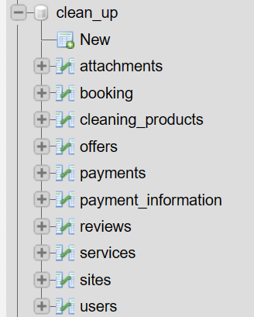

Figure ‑-MySQL Database Tables

Lastly, we will go through the different user types and activities.

**4.3.1 Common Activities Login/Signup and Home Page and Others:**

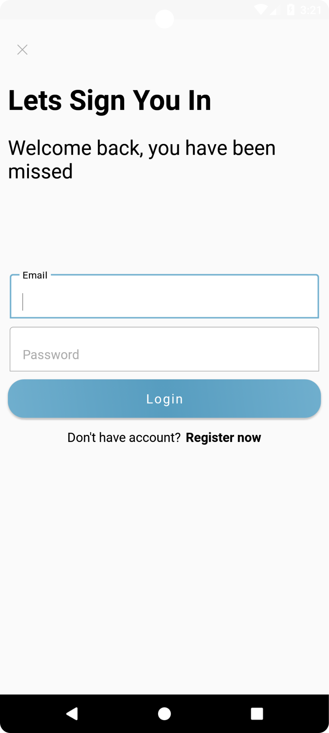

Figure ‑-Sign In Activity

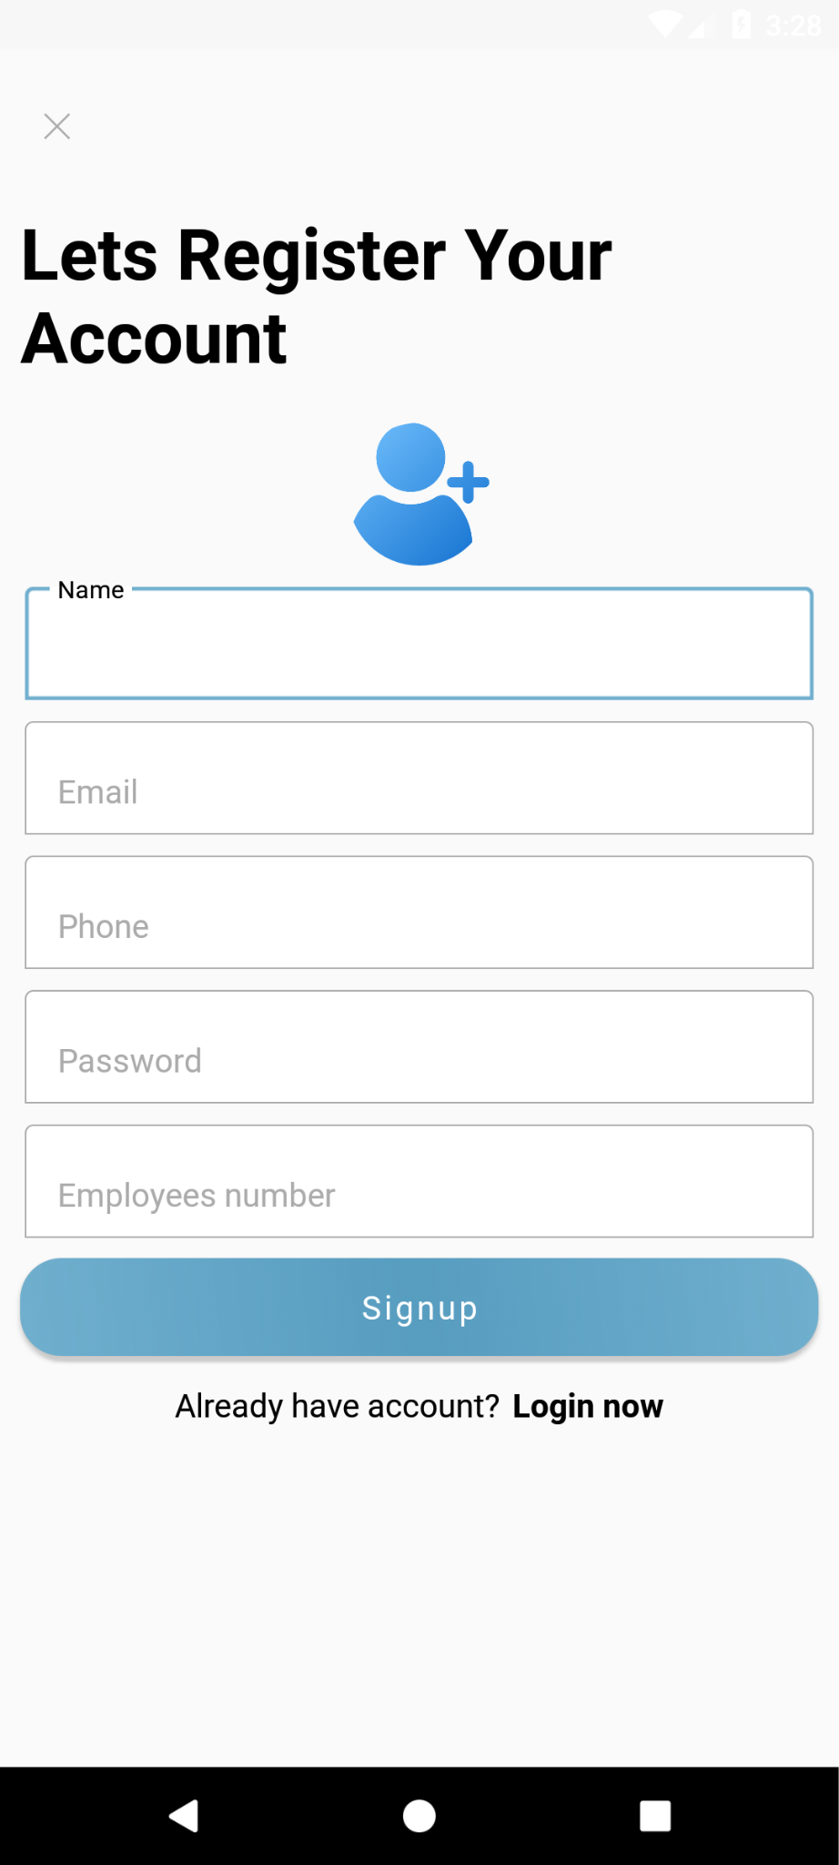

Figure ‑-Registration Activity

The user's journey within the Clean Up system begins with the Login page, which is the initial point of access to the program. Figure 21 depicts the login page, where the user is prompted to enter their username and password. The login process involves the utilization of PHP scripts and the MySQL database to authenticate the user's credentials. If the user does not have an existing account, they will be redirected to select their user type (e.g., company or individual) and subsequently enter their credentials to register to the app.

Upon successful authentication, the user is directed to the home page, where they can access the core functionalities and features of the Clean Up system. The Home page serves as the central hub, providing an overview and easy navigation to various sections and services within the platform.

The Clean Up system offers a user-friendly and visually appealing home page where users can access a variety of features and services. Upon logging in or signing up, users are directed to this central hub, depicted in Figure ‎23. They can browse through categories, discover different companies, and offers. The home page also provides a convenient navigation bar, giving users access to essential features such as bookings, where they can manage reservations, the profile section for viewing and editing personal information, and support for addressing any inquiries. Overall, the home page serves as a comprehensive platform for users to explore services, navigate categories, and utilize key functionalities of the Clean Up system.

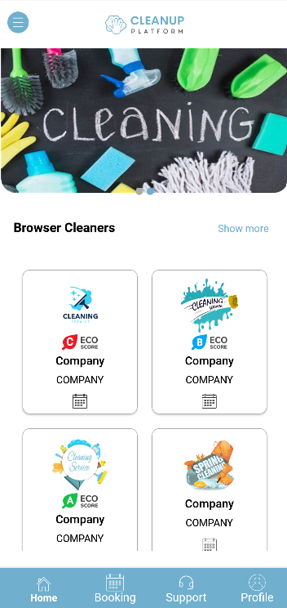

Figure ‑­-Home Page

The Clean Up system offers support and acts as a central hub for addressing customer inquiries and concerns. Users can access information, resources, and contact details to reach the support team, ensuring they receive necessary assistance throughout their experience. Additionally, the app's "About Us" activity provides users with an overview of its concept, goals, mission, vision, and values. By sharing insights into the app's background and intentions, the "About Us" activity aims to establish transparency and build trust with users, enhancing their understanding of the app's purpose and objectives.

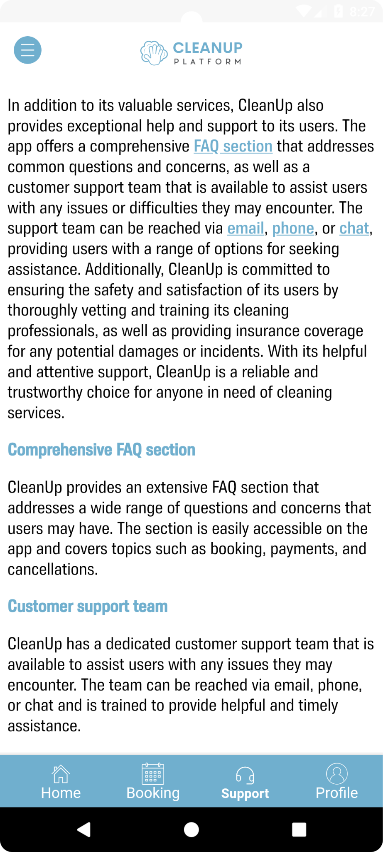

Figure ‑-Support Activity

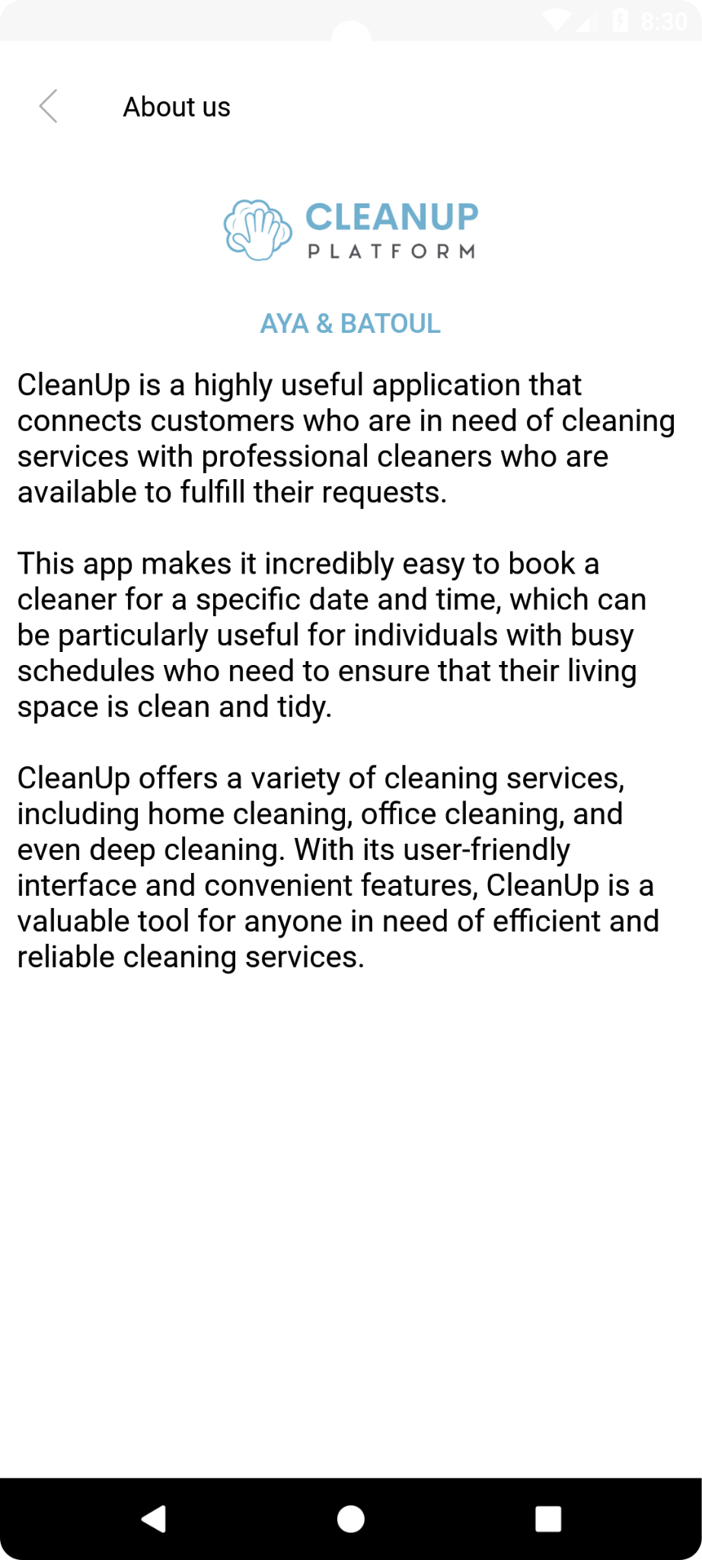

Figure ‑-About Us Activity

In the Clean Up system, users can search through a list of companies and offers using various search criteria. They can search based on location, company name, and price to find specific services or offers that meet their requirements. This search functionality allows users to narrow down their options and find the most relevant and suitable choices based on their preferences.

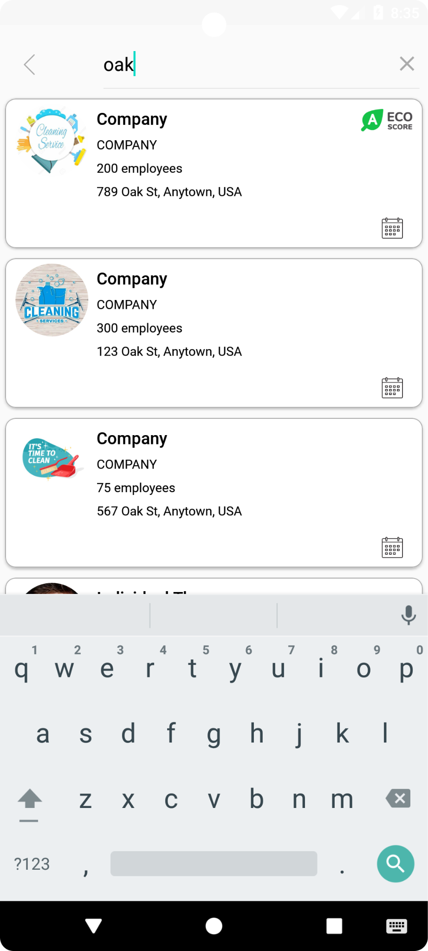

Figure ‑-Advanced Search Option

All users have access to the company profile feature in the Clean Up system, where they can view detailed information such as services, offers, reviews, and the eco-friendly grade of each company. This empowers customers to make informed decisions and choose the best option for their needs. Additionally, administrators can utilize this feature to check for any negative reviews and take necessary actions, such as removing them if required. Moreover, companies can also utilize the company profile feature to keep track of their rivals and stay updated on their offerings and reviews.

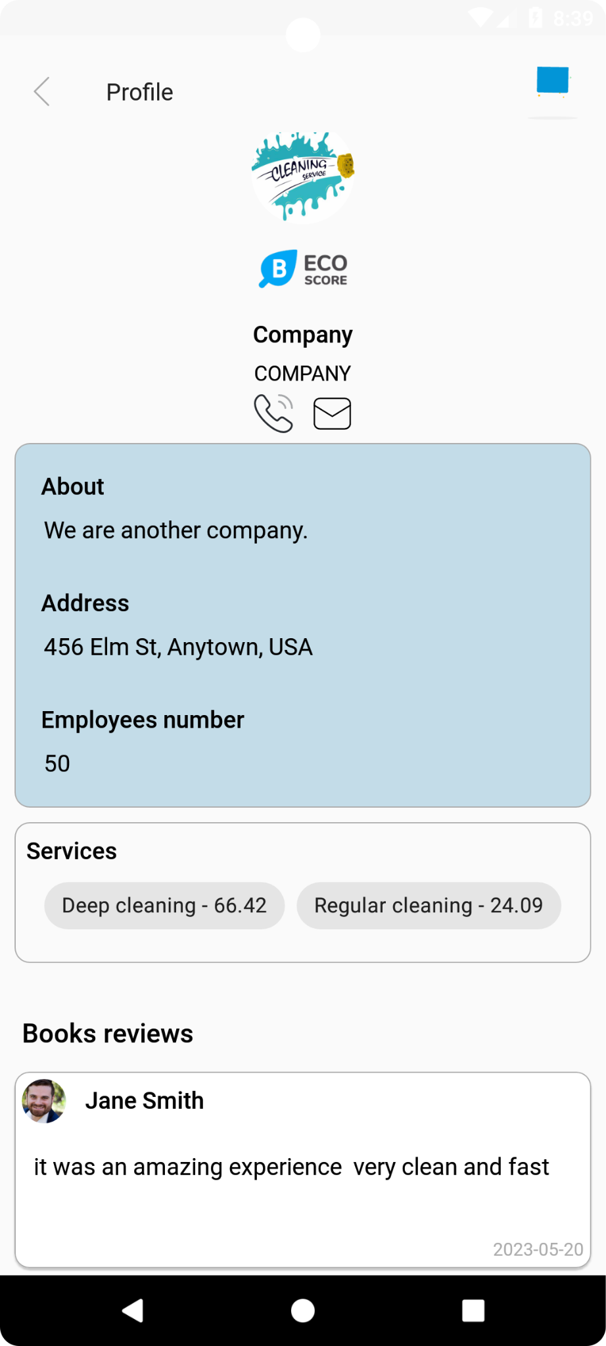

Figure ‑-Company Profile

**4.3.2 Customer Side:**

The Clean Up system's homepage offers a user-friendly interface for customers to browse through various companies and their offers. Once a customer selects a specific company, they can access the company's profile, which provides detailed information about the services offered, reviews from other customers, and available offers. This feature enables customers to make well-informed decisions based on their preferences and requirements.

To proceed with booking a service or offer, customers can add relevant information such as the site where the service is required and specific requirements like the date and time. This information is essential for the booking process. Customers can then request a booking for the desired service or offer, which is subject to acceptance or rejection by the company. Afterward, customers can proceed to select a payment method for the booking where the user can choose the cash option or new or already inserted payment cards, ensuring a convenient and efficient booking experience.

Once a service is booked and completed, customers can review their experience. These reviews play a vital role in establishing the reputation and credibility of the company. When a customer submits a review, it becomes visible on the company's profile, providing valuable feedback and insights for other users who may consider booking their services in the future.

In the booking activity Clicking on a specific booking allows customers to access comprehensive information associated with that booking, including the requested services, date and time, and other relevant details.

In addition to the booking process, customers can update their personal information by accessing the profile activity. They can also view all their bookings in one place, which provides an overview of the status and details of each booking.

In the Clean Up system, customers can view all their sites and perform search or delete actions on them. The system provides a comprehensive list of all the sites associated with the customer's account. Customers can search for specific sites using relevant keywords or filters to quickly locate the desired information. Furthermore, customers have the option to delete any sites that are no longer needed or relevant. This functionality offers convenience and flexibility for customers to manage and organize their site information within the Clean Up system.

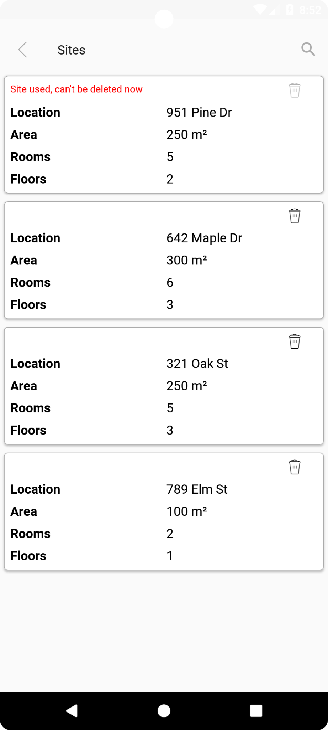

Figure ‑-Customer Sites

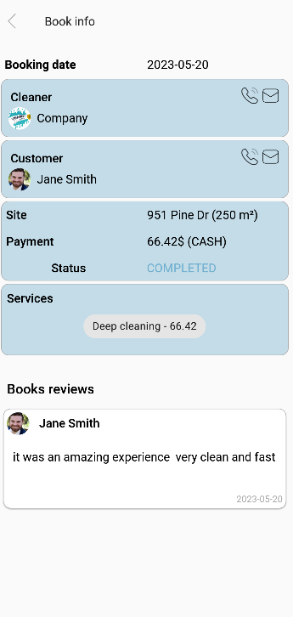

Figure ‑-Booking Details

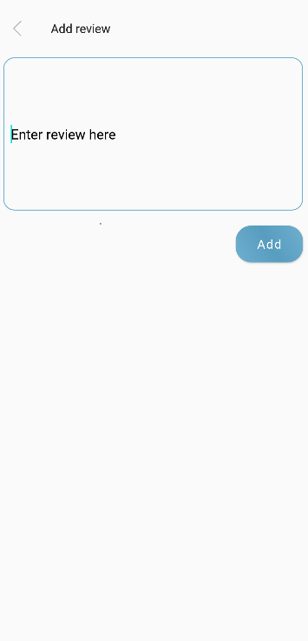

Figure ‑-Adding Review

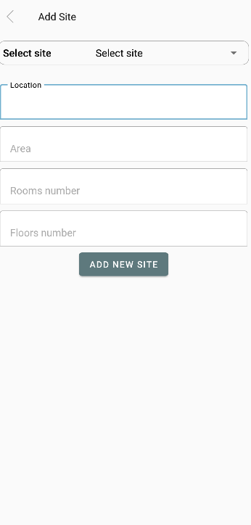

Figure ‑-Adding Site

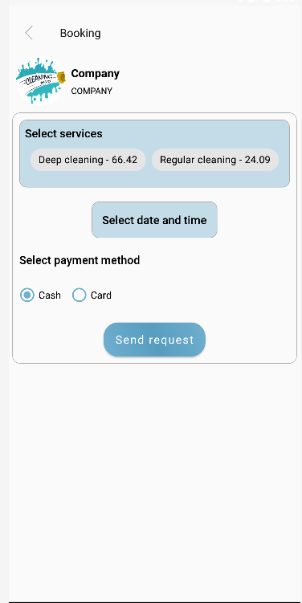

Figure ‑-Adding Booking Details

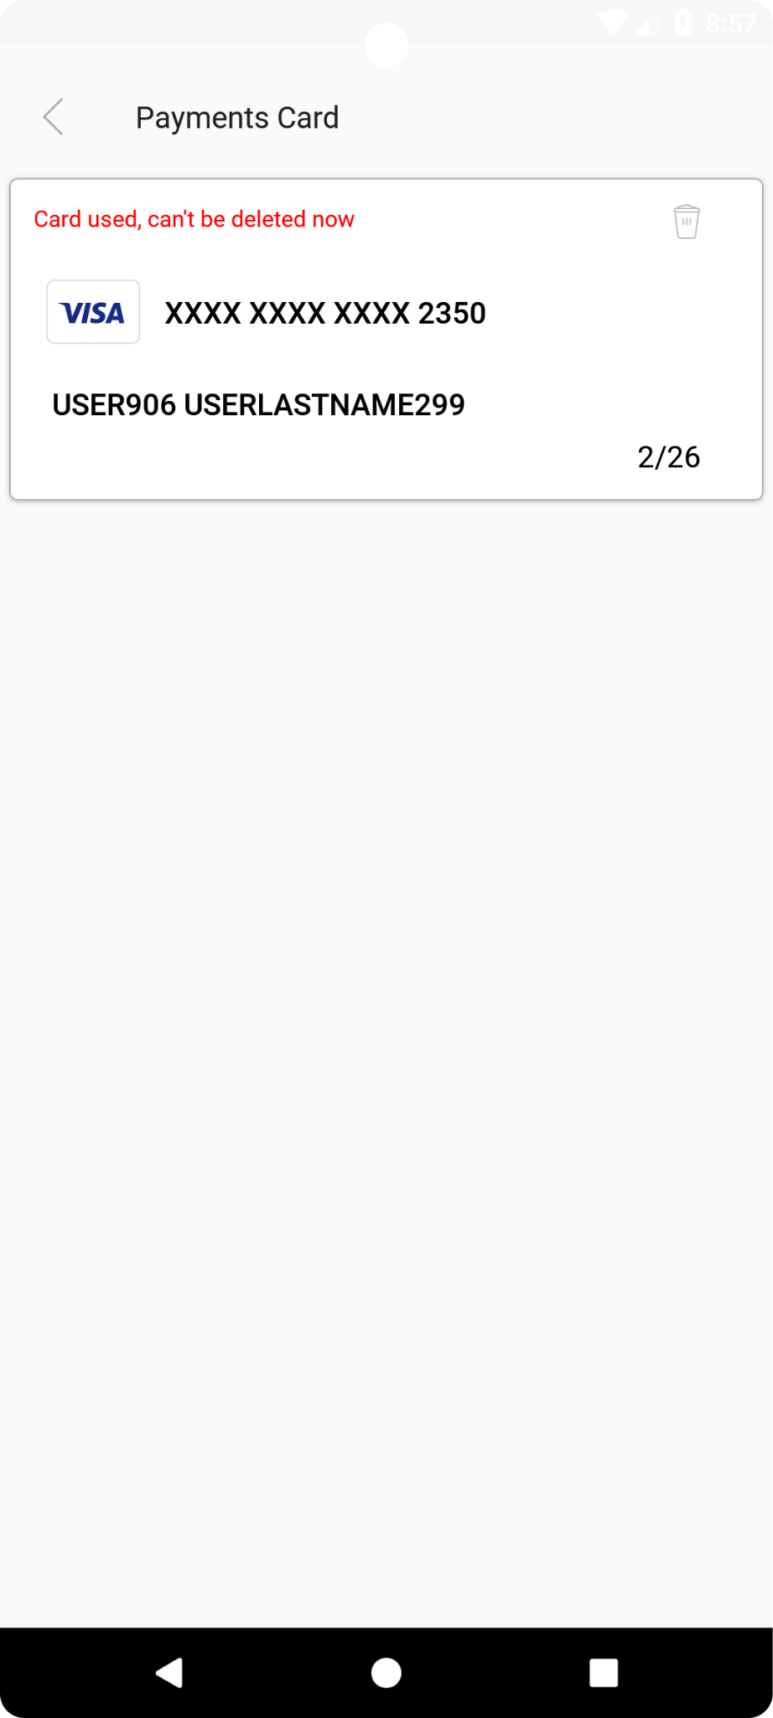

Figure ‑-Customer Cards

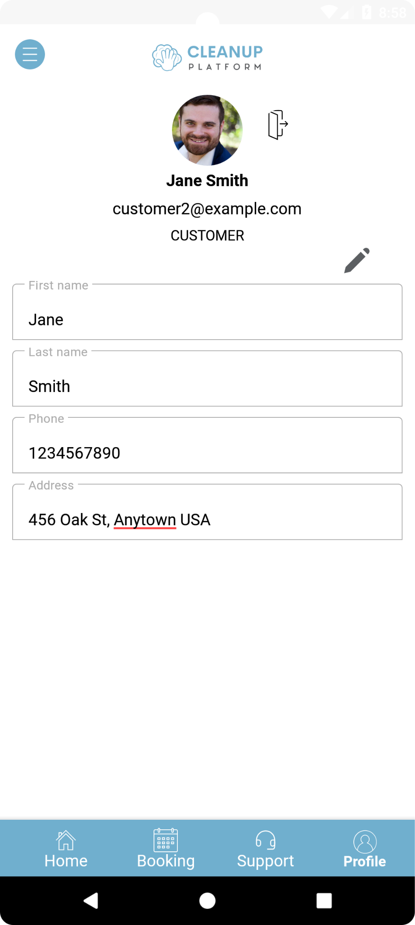

Figure ‑-Customer’s Profile

**4.3.3 Cleaners Side: Company/Individual**

On the Clean Up system's homepage, if the user is a company, they can browse through a diverse selection of companies and offers. By clicking on a specific company, they can access the company's profile, gaining insights into the services offered, customer reviews, and available offers. However, companies in the system cannot directly book services through the homepage. To manage bookings, companies can navigate to the dedicated bookings activity. Here, they can view all the bookings received and can modify the booking status. They can update the status as rejected, accepted, or completed based on the progress of the cleaning service. Additionally, companies can provide reasons for rejecting a booking, ensuring effective communication with customers. The profile section empowers companies to edit their information as needed. They have the flexibility to disable specific dates where no bookings will be accepted, effectively managing their availability. Furthermore, companies can add services they offer and specify the cleaning products they use, providing transparency and allowing customers to make informed choices.

Companies using the Clean Up system can access the "Offers" activity, which allows them to view all their offers in one place. This activity provides a comprehensive overview of the company's offers. Companies also have the option to delete offers if needed, giving them control over their offerings. Similarly, companies can navigate to the "Reviews" activity, where they can see all the reviews received by their company. This activity provides a consolidated view of customer reviews, including ratings and feedback. Companies can gain insights into their performance and reputation through these reviews and make informed decisions to improve their services based on customer feedback.

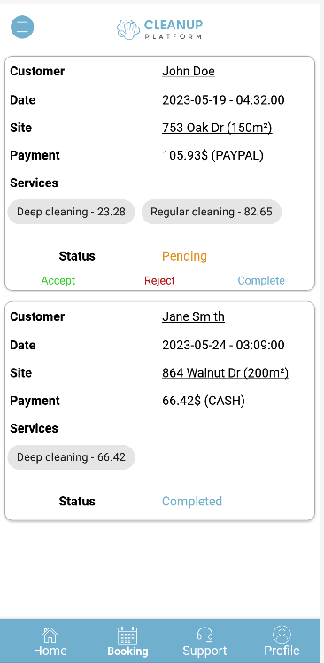

Figure ‑-Company’s Booking Activity

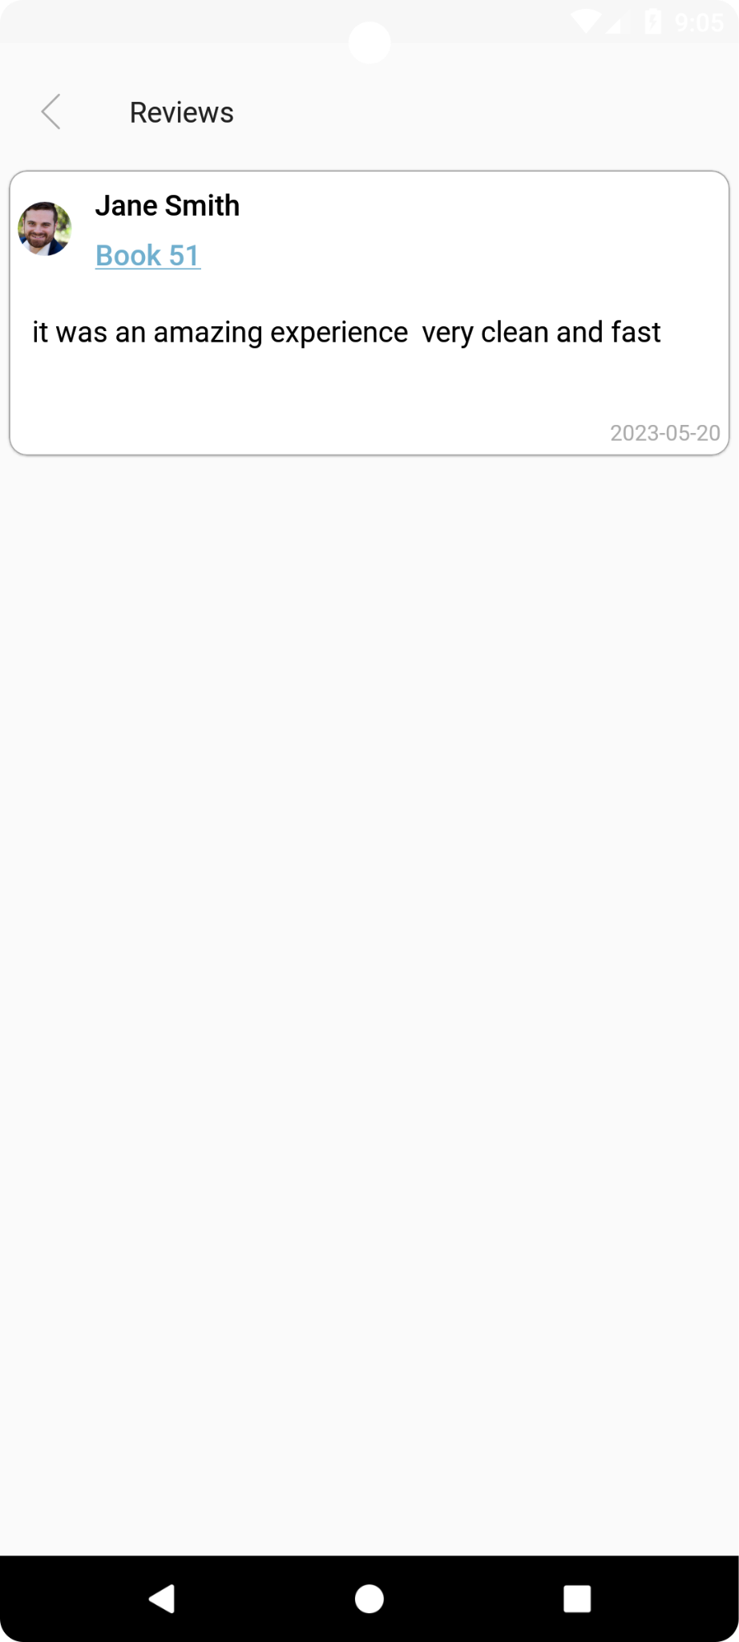

Figure ‑-Company’s Reviews

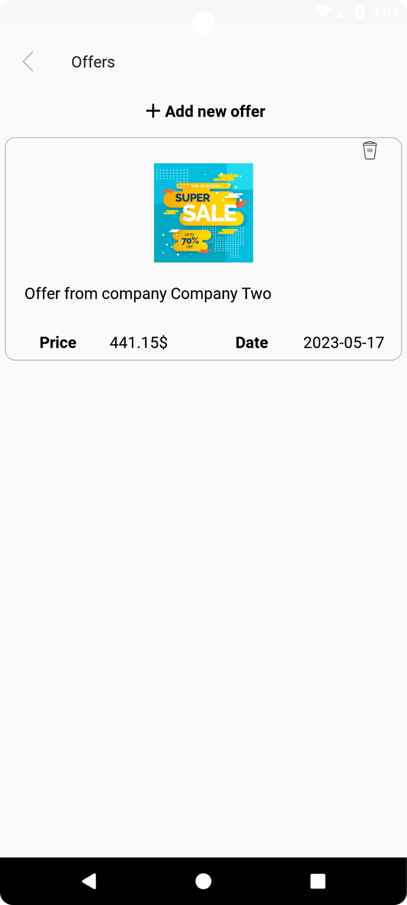

Figure ‑-Company’s Offers

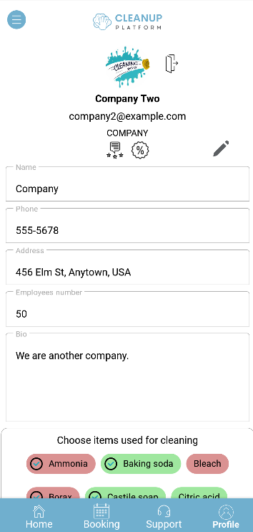

Figure ‑-Company’s Profile

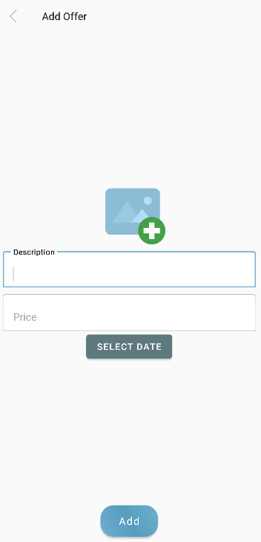

Figure ‑-Adding Offers

1. **Admin Side**

The admin in Cleanup has the authority to take actions such as removing cleaners with poor reviews and users who engage in offensive behavior. They also have the capability to modify the homepage images, view payment information, add new products to the platform, and indicate whether a product is eco-friendly or not. These administrative controls ensure the maintenance of quality standards, user safety, and the ability to curate and update the platform effectively.

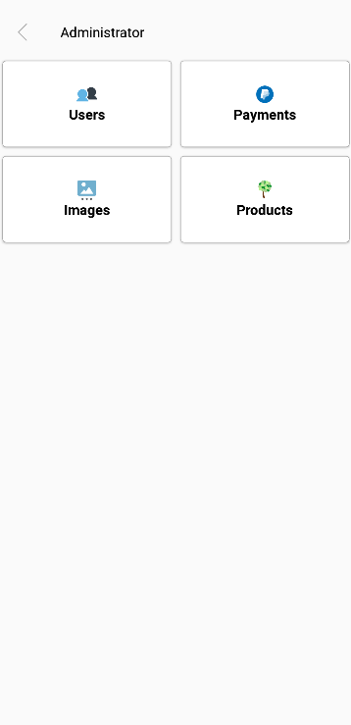

Figure ‑-Admin Actions

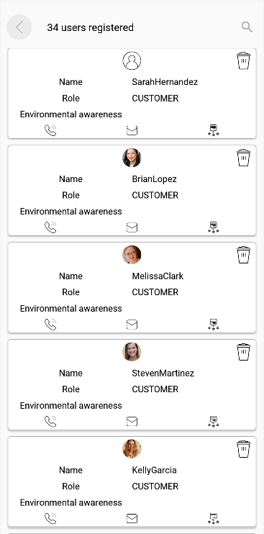

Figure ‑-All Users

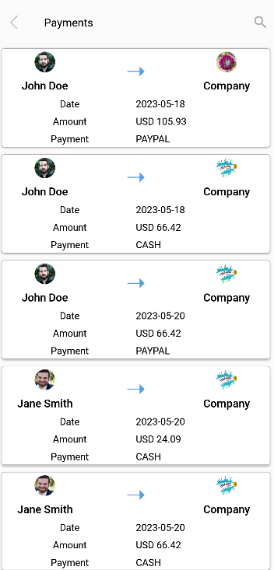

Figure ‑-All Payments

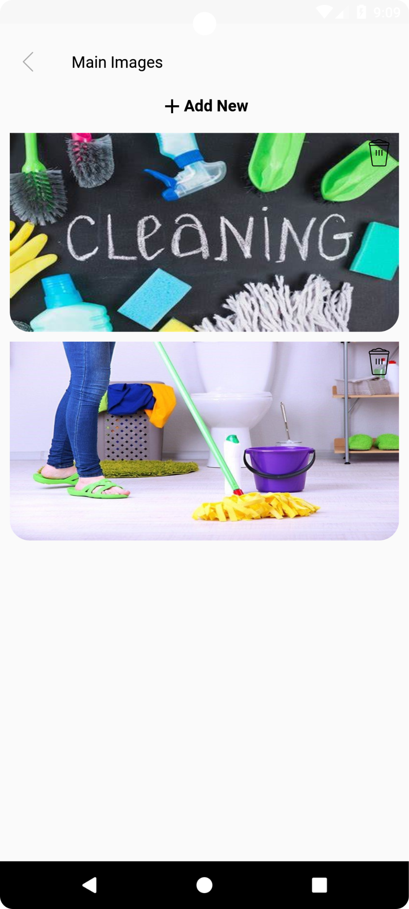

Figure ‑-Main Images

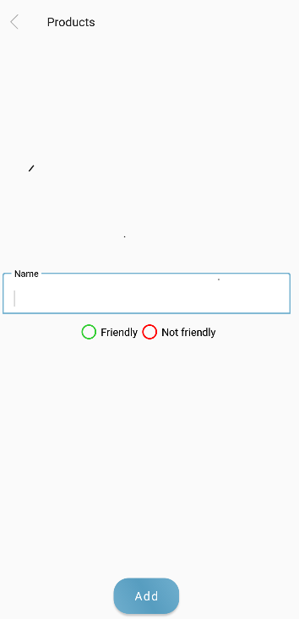

Figure ‑-Adding Products

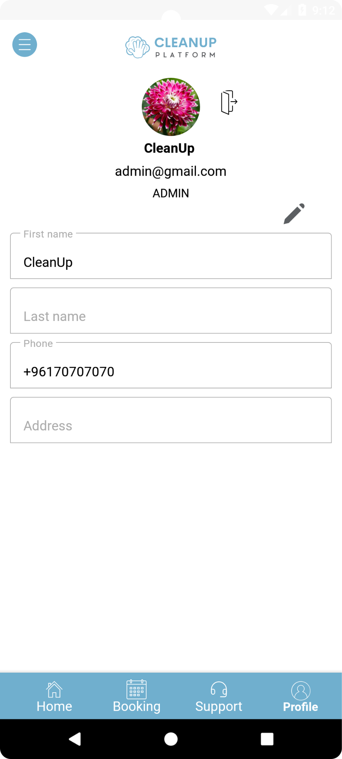

Figure ‑-Admin Profile

## Eco-Friendly Rating Criteria

$$\%score=\frac{items_ef}{items_t} ×100$$

Legends:

% score: percentage of eco-friendliness

Items_ef: number of eco-friendly products

Items_t: total number of products

The rating of an eco-friendly company is determined by assessing the percentage of eco-friendly products it incorporates. The resulting rating is categorized according to the following scale: A: (100%), B: (90-99%), C: (80-89%), D: (70-79%), E: (60-69%) and F: (0-59%). This rating system provides a clear and concise representation of a company's eco-friendliness, allowing stakeholders to evaluate its commitment to sustainable practices. Aligning the ratings with specific percentage ranges offers a straightforward understanding of a company's environmental impact and encourages continuous improvement in adopting more eco-friendly products.

## Test Cases and Acceptance Criteria

After the implementation of the app, we proceeded with the testing phase to ensure the proper functioning of all components and features.

**Test Case 1: Login Functionality**

Test Steps:

* Enter a valid username and password.
* Click on the login button.
* Verify that the user is successfully logged in and redirected to the home page.

Acceptance Criteria:

* The user should be able to log in with valid credentials.
* After successful login, a toast message (Success) should appear, and the user should be directed to the home page.

Case of failure:

* Users insert an email address that does not exist a toast message (mail the mail does not exist) appears.
* Users insert a wrong password or message a toast message (email or password is incorrect) appears.

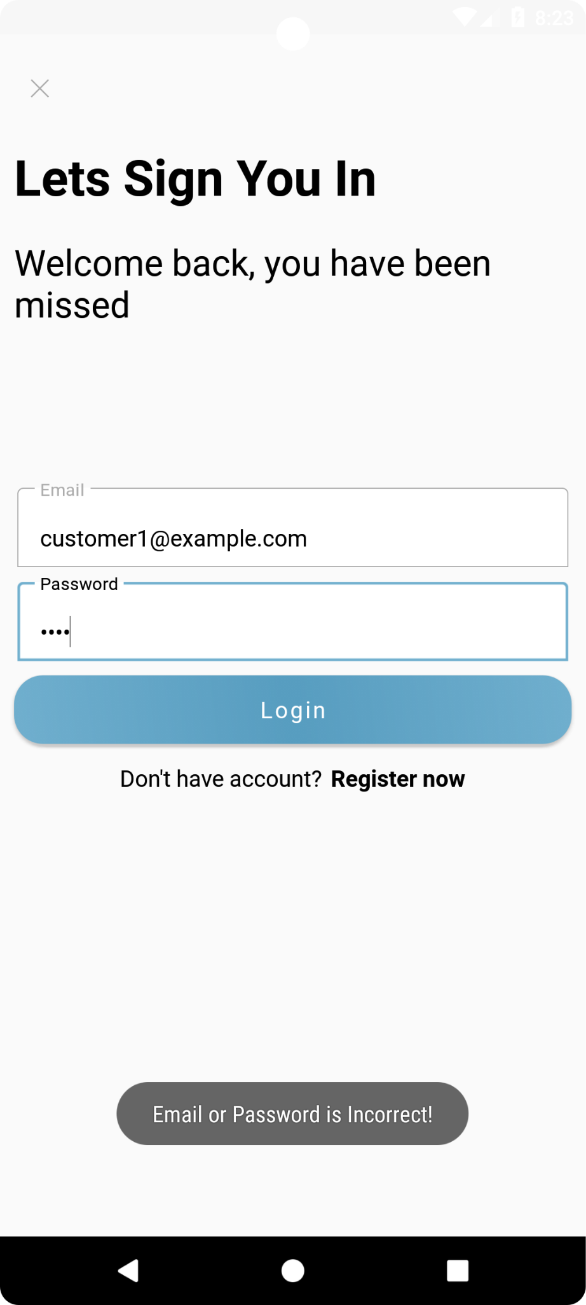

Figure ‑-Wrong Credentials

**Test Case 2: Booking a Service**

Test Steps:

* Select a company or offer from the available options.
* Provide the required details such as service name, site, date, and time.
* Choose a payment method.
* Click on the "Send Request" button.
* Verify that the booking is successfully created, and a confirmation message is displayed (request sent).

Acceptance Criteria:

* The user should be able to select a service, enter the necessary details, and choose a payment method.
* Upon successful booking, a confirmation message should be displayed.

Case of failure:

* The user miss-entered any of the required details in a toast message (the missing detail is required).

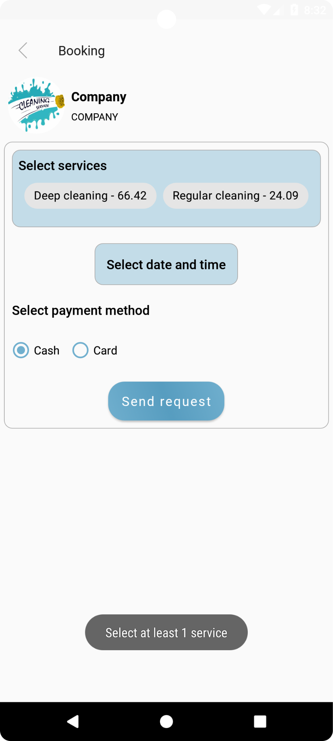

Figure ‑-Case of Missing Detail

**Test Case 3: Removing a Cleaner or Customer**

Test Steps:

* Access the admin panel.
* Navigate to the list of users.
* Select the specific user to be removed.
* Click on the "Remove" button.
* Verify that the user is successfully removed from the system.

Acceptance Criteria:

* The admin should have the ability to access the list of users.
* The admin should be able to remove a selected user from the system.

Case of failure:

The removal of a user is not successful due to issues such as insufficient privileges, technical errors, or other exceptional circumstances.

**Test Case 4: Review Submission**

Test Case Description: The user should be able to submit a review for a completed booking.

Precondition: A booking has been completed by the user.

Test Steps:

* Login to the Clean Up system as a user.
* Navigate to the completed booking for which a review needs to be submitted.
* Enter a review for the service received.
* Click on the "Add" button.

Acceptance Criteria:

* The review should be successfully submitted and associated with the respective booking.
* The review should be visible on the company's profile page.

Case of failure:

* The user left the review empty, and the system should display an error message indicating that the user is required to add a review.

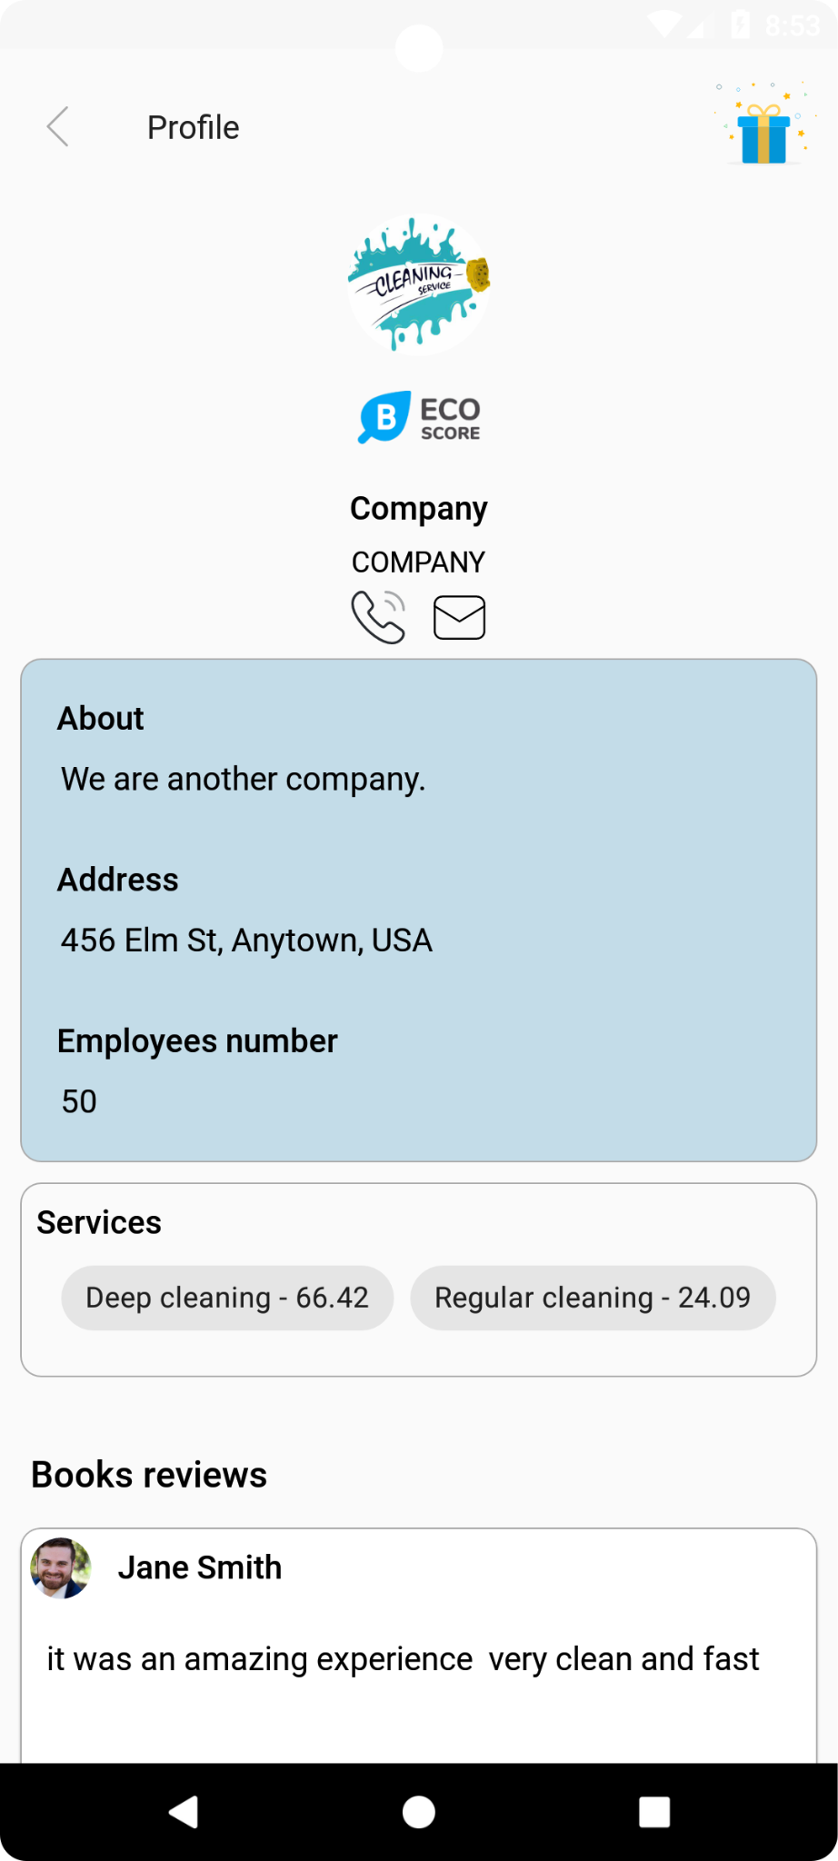

Figure ‑-Case of Successful Review

## Conclusion

The implementation phase of the Cleaning Up application was executed successfully, utilizing Java, XML, PHP, and MySQL as the primary languages. These languages were chosen for their familiarity, platform suitability, extensive ecosystems, and adherence to industry standards. The implementation process included the development of key features such as the login/signup process, homepage, booking functionality, and administrative controls.

Test cases and acceptance criteria were employed to ensure the proper functioning of the implemented features, covering scenarios such as login, booking services, and removing users. This rigorous testing approach helped validate the application's functionality and identify any potential failures.

Overall, the implementation phase transformed the initial design into a functional and user-friendly application. The chosen languages and tools, along with thorough testing, contributed to the development of a reliable and robust system. The implementation process highlighted the importance of selecting appropriate technologies and conducting comprehensive testing to deliver a high-quality product.

# Conclusion and Future Work

## Conclusion

The development of the cleanup platform has been a valuable learning experience. Despite the challenges posed by limited resources, we were able to create a functional and user-friendly app that connects companies and individuals with professional cleaning services. Through this project, we have gained insights into the complexities of developing a service-oriented platform and the importance of prioritizing user needs and preferences. One of the key lessons learned is the significance of effective communication and collaboration. As a team, we navigated through various tasks and challenges by maintaining open lines of communication, sharing ideas, and leveraging each other's expertise. This experience highlighted the importance of teamwork and coordination in achieving project goals.

Moreover, The Cleanup project provided us with valuable experience in mobile development, UI/UX design, and database management. We gained expertise in creating user-friendly interfaces, optimizing mobile performance, and implementing efficient data management practices. We learned the importance of continuous improvement in user experience through user feedback, usability testing, and monitoring user behavior. Overall, the project equipped us with the necessary skills to deliver high-quality mobile applications and enhance user satisfaction in the future.

The experience of developing the Cleanup mobile app demonstrated to us that with thorough preparation, adaptability, and the right mindset, anything is achievable. Despite encountering challenges and moments of uncertainty throughout the journey, we managed to overcome obstacles and forge ahead. The project has been a significant undertaking, and we eagerly anticipate its promising future and successful outcomes.

## Future Work

During the development of this project, numerous features were considered for potential inclusion. The following features can be useful for the future of this project:

1. Eco-friendly cleaning products shop: Adding a section within the app where users can purchase eco-friendly cleaning products would complement the cleaning services provided. This feature can promote sustainability and cater to users who prefer environmentally friendly options. You can partner with eco-friendly cleaning product suppliers to offer a range of products and provide users with a convenient way to purchase them through the app.
2. Direct chat with companies: Introducing a chat functionality that enables direct communication between users and companies to improve customer experience and streamline the process. Users can ask questions, provide specific instructions, and receive real-time updates from the cleaning companies. This feature promotes transparency, ensures clear communication, and allows for immediate problem resolution if any issues arise.
3. Real-time tracking: Implement a real-time tracking feature that allows users to track the progress of their cleaning service. Users can see the current location of the cleaner, estimate the time of arrival, and receive notifications when the cleaning is complete. This feature enhances transparency and provides users with peace of mind knowing the status of their service.
4. Quality assurance and certifications: Establish a system for verifying and certifying the professional cleaners on the platform. This can include background checks, verification of qualifications or certifications, and ongoing performance evaluations. By ensuring the quality and professionalism of the cleaners, you can build trust and confidence among users.

**APPENDIX A:  
 USER Manual**

Kindly find the link to the source code: [10]

<https://github.com/batoulsla/Cleanup_sourcecode>

User Manual: Cleanup Platform

1. Introduction:

Welcome to the Cleanup platform! This user manual will guide you through the features and functionalities of the cleanup app, enabling you to easily book and manage cleaning services with professional cleaners. Whether you are an individual or a company in need of reliable and affordable cleaning services, Cleanup has you covered.

2. Getting Started:

2.1 Creating an Account:

To access the Cleanup platform, you need to create an account. Download the Cleanup app from your app store and follow the on-screen instructions to sign up. Provide the required information, such as your name, email address, and password, to create your account successfully.

2.2 Logging In:

Once you have created an account, you can log in to the CleanUp app using your registered email address and password. Enter your credentials in the login screen and tap the "Log In" button.

3. Booking a Cleaning Service:

3.1 Selecting Service Type:

On the Cleanup app's home screen, choose the type of cleaning service you require, such as one-time cleaning, regular cleaning, or deep cleaning. Select the appropriate option to proceed.

3.2 Choosing Date and Time:

Specify the date and time that works best for you. Use the calendar and time picker to select the desired cleaning schedule.

3.3 Customizing Cleaning Plan:

Customize your cleaning plan by indicating specific areas to focus on, preferred cleaning products, or any additional instructions. This step allows you to tailor the cleaning service to your unique needs.

4. Finding and Selecting a Cleaner:

4.1 Searching for Cleaners:

After customizing your cleaning plan, the app will display a list of available cleaners in your area. You can refine the search results by applying filters such as eco-friendly grading or customer ratings.

4.2 Viewing Cleaner Profiles:

Click on a cleaner's profile to view detailed information, including their experience, specialties, and service offerings. Take note of the customer reviews and ratings to make an informed decision.

4.3 Reading Customer Reviews:

Customer reviews provide insights into the quality of service a cleaner offer. Read the reviews to understand previous customers' experiences with the cleaner.

4.4 Selecting a Cleaner:

Once you have reviewed the cleaner's profile and customer feedback, select the desired cleaner by tapping the "Book Now" button on their profile.

5. Managing Bookings:

5.1 Viewing Upcoming Bookings:

To view your upcoming bookings, go to the "My Bookings" section within the app. You can see the date, time, and details of each scheduled cleaning service.

5.2 Modifying or Canceling Bookings:

If you need to modify or cancel a booking, navigate to the "My Bookings" section, and select the specific booking you wish to modify. Follow the prompts to make the necessary changes or cancel the booking.

6. Eco-Friendly Grading:

6.1 Understanding Eco-Friendly Grades:

CleanUp assigns eco-friendly grades to clean companies based on their commitment to environmentally friendly practices. Higher grades indicate a stronger dedication to eco-friendly cleaning.

6.2 Selecting Eco-Friendly Cleaning Companies:

When searching for cleaners, pay attention to their eco-friendly grades. You can filter search results to prioritize eco-friendly cleaning companies and choose the one that aligns with your environmental values.

7. Payment and Scheduling:

7.1 Making a Payment:

CleanUp provides secure payment options. After confirming your booking, proceed to the payment screen and select your preferred payment method. Follow the instructions to complete the payment process.

7.2 Managing Payment Methods:

To manage your payment methods, navigate to the "Payment" section in your account settings. Add, remove, or update your payment information as needed.

7.3 Scheduling Recurring Cleanings:

If you require regular cleaning services, CleanUp allows you to schedule recurring cleanings. Choose the desired frequency (e.g., weekly, bi-weekly, monthly) and set the preferred day and time for each recurring cleaning.

8. Account Settings:

8.1 Updating Profile Information:

Keep your profile information up to date by visiting the "Account Settings" section. Update your name, contact details, and address, as necessary.

8.2 Managing Notifications:

Configure your notification preferences in the "Account Settings" section. Choose how you want to receive alerts and updates about your bookings and accounting activity.

8.3 Changing Password:

To change your account password, go to the "Account Settings" section and select the "Change Password" option. Follow the provided instructions to set a new password.

9. Frequently Asked Questions (FAQs):

Refer to the Frequently Asked Questions section within the app for answers to common inquiries. This section provides additional information and guidance on various topics related to the CleanUp platform.

10. Contacting Customer Support:

If you have any further questions or require assistance, you can reach out to CleanUp's customer support team. Find the contact information in the app's "Contact Support" section and follow the provided instructions.

**APPENDIX B:   
deployment and configuration Manual**

1. Prerequisites:

- Android Studio: Ensure that you have Android Studio installed on your development machine.

- XAMPP: Install XAMPP, which provides an easy way to set up and configure a local server environment.

2. Setting up the Server:

- Launch XAMPP and start the Apache and MySQL services.

- Open a web browser and navigate to "http://localhost/phpmyadmin" to access the PHPMyAdmin interface.

- Create a new database named "clean_up" and import the provided SQL file to set up the necessary tables and data.

3. Setting up the Android Project:

- Open Android Studio and import the CleanUp project.

- Ensure that you have the necessary Android SDK versions and dependencies installed. Android Studio will prompt you to install any missing components.

- Open the "build. gradle" file for the app module and build the project.

4. Configuring the Server URL:

- Open the project in Android Studio and navigate to the "Config" java file located in the "utilities" package.

- Update the value of the "IP" constant to the URL where your server is hosted. For local development, it should be something like "http://localhost/cleanup_api/"

5. Building and Running the App:

- Connect an Android device or start an emulator.

- Click on the "Run" button in Android Studio to build and install the app on the connected device/emulator.

- Once the app is installed, launch it on the device.

Troubleshooting Techniques:

- If you encounter build errors in Android Studio, make sure that all dependencies are properly configured and that the necessary SDK versions are installed.

- If the app fails to connect to the server, check the server URL in the "Utilities " file and ensure that the server is running and accessible from the device/emulator.

- If you face any database-related issues, double-check the database configuration in the XAMPP control panel and ensure that the necessary tables and data are imported correctly.

# References

|  |  |
| --- | --- |
| [1] | T. Team, "Challenges and Opportunities Facing Cleaning Businesses," 2022. [Online]. Available: https://www.tennantco.com/en_ca/resources/resource-center/white-papers/cleaning-business-challenges-and-opportunities.html. [Accessed 3 March 2022]. |
| [2] | S. Team, "Industries with the highest levels of employment of janitors and cleaners in the United States in 2022," May 2023. [Online]. Available: https://www.statista.com/statistics/324433/industries-with-the-highest-levels-of-employment-of-janitors-and-cleaners-us/. [Accessed 3 March 2023]. |
| [3] | "Handy," October 2012. [Online]. Available: https://www.handy.com/. [Accessed 21 May 2023]. |
| [4] | "Reviews," 2022. [Online]. Available: https://www.sitejabber.com/reviews/handy.com. [Accessed 2023 March 3]. |
| [5] | " Tidy," [Online]. Available: https://www.tidy.com/. [Accessed 26 March 2023]. |
| [6] | "Tidy.com Reviews," [Online]. Available: https://www.revdex.com/reviews/tidycom/8881921. [Accessed 3 March 2023]. |
| [7] | "TaskRabbit," [Online]. Available: https://www.taskrabbit.com/. [Accessed 4 March 2023]. |
| [8] | "Reviews," [Online]. Available: https://www.trustpilot.com/review/taskrabbit.co.uk. [Accessed 4 March 2023]. |
| [9] | "Mediafire," [Online]. Available: https://www.mediafire.com/file/1k2ty66rc0svemt/svgviewer-png-output.png/file. [Accessed 26 May 2023]. |
| [10] | "Source Code," [Online]. Available: https://github.com/batoulsla/Cleanup_sourcecode. [Accessed 31 May 2022]. |